|  |
| --- |
| User Manual  Order to cash |
| REFERENCE: GW/ERP/USER MANUAL |
|  |
| **Genweb2 Ltd.** |
|  |



|  |
| --- |
|  |

# Document Information

|  |  |
| --- | --- |
| Document Name | User manual for Order to cash |
| Document Author | Rashedul Alam |
| Document Version | 1.2 |
| Release Date | 30th June, 2020 |

|  |  |
| --- | --- |
| 1st Review by | Md. Matiar Rahman |
| Review Date | 12th Dec, 2018 |
| 2nd Review by | Md. Mahfuzur Rahman |
| Review Date | 30th June, 2020 |
| Approved By | Md. Mahfuzur Rahman |
| Approval Date | 30th June, 2020 |

# Document History

|  |  |  |  |  |  |
| --- | --- | --- | --- | --- | --- |
| A=Added, M=Modified, D=Delete | | | | | |
| **Version No** | **Date** | **Section No** | **A/M/D** | **Description of Change** | **Author** |
| 1.0 | 11-April-2018 |  | A | Initial | Rashedul Alam |
| 1.1 | 11-Dec-2018 |  | A |  | Rashedul Alam |
| 1.2 | 28-June-2020 |  | A & M | **Modify:** Cumtomer ,Product,Customer credit limit,Customer commission,Product sales price list.proforma invoice local,Quotation local,Delivery Authorization,Delivery order,Delivery chalan,Cheque received  **Modify reports**: Proforma invoice,Sales order ,Customer credit limit,Customer commission,,Product sales price list,Delivery order,Sales analysis.  **Add**: Proforma invoice(Foreign),Quotation foreign,Sales order local & foreign, Foreign view,Customer collection,Customer collection batch,LC collection  **Add reports**:Executive sales(Product/country wise),Customer sales(Product/country wise),Customer sector wise,Sector product wise,Outstanding statement,Credit details,Yearly sales comparison,motnhly delivery statement executive wise, motnhly delivery statement product wise. | Rashedul Alam |

Contents

A. Document Information 2

B. Document History 2

1. Introduction 6

1.1 Purpose of User Manual 7

2. Customer 7

2.1 Customer creation by Customer Manager 7

3. Products 8

3.1 Product creation by Product Manager 9

4. Customer credit limit 10

4.1 Create customer credit limit by Sales Executive/Head of sales 11

4.2 Customer credit limit approval by Head of Sales 12

4.3 Customer credit limit Validate by Head of accounts 13

4.4 Customer credit limit approve by CXO 14

5. Customer Commission 15

5.1 Create customer commission by Sales executive/Head of sales 15

5.2 Customer commission approval by Head of Sales 16

5.3 Customer commission Validate by Head of accounts 17

5.4 Customer commission approval by CXO 18

6. Product Sales Pricelist 20

6.1 Create product sales pricelist by Sales executive/Head of sales 20

6.2 Product sales pricelist Approve by head of sales 21

6.3 Product sales pricelist Validate by Head of accounts 22

6.4 Product sales pricelist Approve by CXO 23

7. Variant history 24

7.1 Variant history view by Sales user 24

8. Generate commission 25

8.1 Create Generate commission by Accounts executive/Head of accounts 25

8.2 Generate commission Approve by Accounts executive/Head of accounts 26

9. Proforma Invoice (Local) 27

9.1 Create Proforma Invoice by Local Sales executive 27

10. Proforma Invoice (Foreign) 28

10.1 Create Proforma Invoice by Foreign Sales executive 28

11. Quotation (Local) 30

11.1 Create Quotation local by Sales executive 30

11.2 Quotation approval by head of sales 32

11.3 Quotation validate by head of account 33

11.4 Quotation approve by CXO 34

12. Sales Order (Local) View 36

12.1 View Sales order by Sales User 36

13. Quotation (Foreign) 36

13.1 Create Quotation Foreign by Sales executive 36

13.2 Quotation approval by head of sales 38

13.3 Quotation validate by head of accounts 39

13.4 Quotation approve by CXO 40

14. Sales Order (Foreign) View 42

14.1 View Sales order by Foreign Sales User 42

15. Delivery Authorization 42

15.1 Confirm DA by Account head/Account Executive 43

15.2 DA Approval by Account head 44

16. Delivery Order 45

16.1 Delivery order view by accounts executive/accounts head 45

17. Delivery Chalan 45

17.1 Delivery chalan validate by Delivery man 45

18. Delivery Schedules 47

18.1 Create Delivery Schedule by Sales executive 47

19. Delivery Instruction 48

19.1 Delivery instruction view by Delivery operation 48

20. Customer Invoice 49

20.1 Customer Invoice Validate by Accounts executive 49

21. Cheque Received 50

21.1 Cheque Received by Accounts executive 50

22. Customer Collection 52

22.1 Create Customer collection by Accounts executive 52

23. Customer Collection Batch 53

23.1 Create Customer collection batch by Accounts executive 53

24. LC Collection 54

24.1 Create LC collection by Accounts executive 54

25. Reports 56

25.1 Proforma Invoice reports (Local & Foreign) view by Sales executive 56

25.2 Sales Order reports (Local & Foreign) view by Sales executive 58

25.3 Customer credit limit reports view by Admin 61

25.4 Customer commission reports view by Admin 62

25.5 Product sales pricelist reports view by Sales executive 63

25.6 Delivery Order reports view by account head 64

25.7 Sales Analysis reports view by CXO 66

25.8 Executive Sales Reports (Area/Country wise) view by Admin 67

25.9 Customer Sales Reports (Area/Country wise) view by Admin 68

25.10 Customer Sector wise sales reports view by Admin 69

25.11 Sector product wise sales reports view by Admin 70

25.12 Outstanding Statement reports view by Admin 71

25.13 Credit Details (Product) reports view by Admin 72

25.14 Yearly Sales Comparison reports view by Admin 73

25.15 Monthly Delivery statement (Executive wise) reports view by Admin 74

25.16 Monthly Delivery statement (Product wise) reports view by Admin 75

# 1. **Introduction**

The User Manual contains all essential information for the user to make full use of the information system. This manual includes a description of the system functions and capabilities, contingencies and alternate modes of operation, and step-by-step procedures for system access and use.

## Purpose of User Manual

The purpose of this User Manual is to clearly identify the customer requirements and provide a detailed document. The customer will read this document and get a clear view of the sales module.

This document is the User Manual of the Order to cash process. It is intended to provide all the necessary information to use this software to develop application software running on the workstation.

# 2. Customer

Customer profile is the place where customer’s information stored.

There will be two types of customer for the sales module.

1. Local Customer

2. Foreign Customer

## 2.1 Customer creation by Customer Manager

Customer will be created/Edited by Customer Manager. Customer can be created company wise.

Customer Manager can create customer using the menu **sales ‣ Customer** and click **Create.**

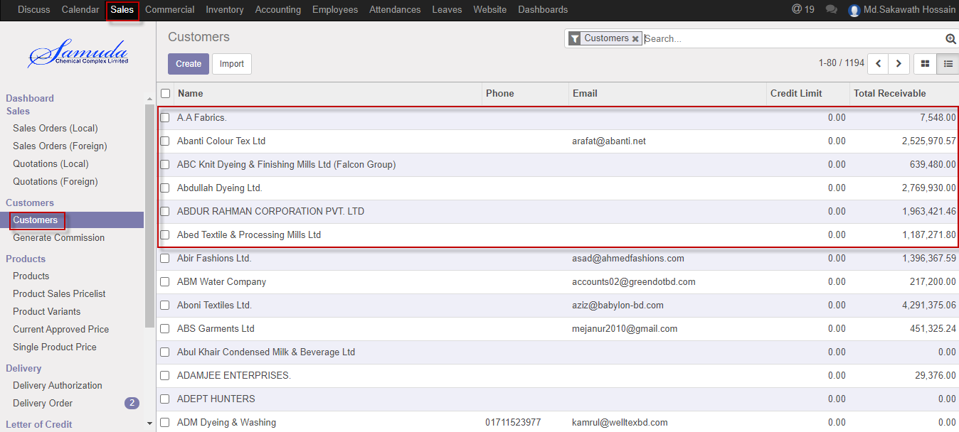

Figure: Customer List view

We need to set the following:-

N**ame**: Enter a customer name.

**Job position:** Enter job position.

**Address:** Enter address.

**Phone:** Enter Phone.

**Mobile:** Enter mobile number.

**Email:** Enter email.

**Tags:** Enter tags.

**Trade license:** Enter a trade license.

**Vat registration:** Enter a vat registration.

**BIN Number:** Enter a Bin Number

**TIN Number:** Enter a Tin Number

After entering all information click **Save**.

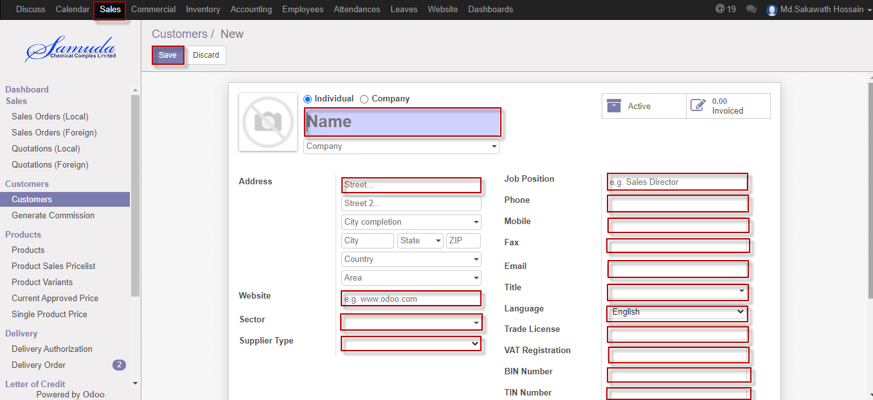

Figure: Create a customer

# 3. Products

Samuda ERP system has two types of product: Sales product, Purchase product.

Sales product will be created by Sales department & on the other hand Purchase product will be created by Purchase department.

## 3.1 Product creation by Product Manager

Product will be created/Edited by sales Product Manager.

Product Manager can create product using the menu **Sales ‣ products** and click **Create.**

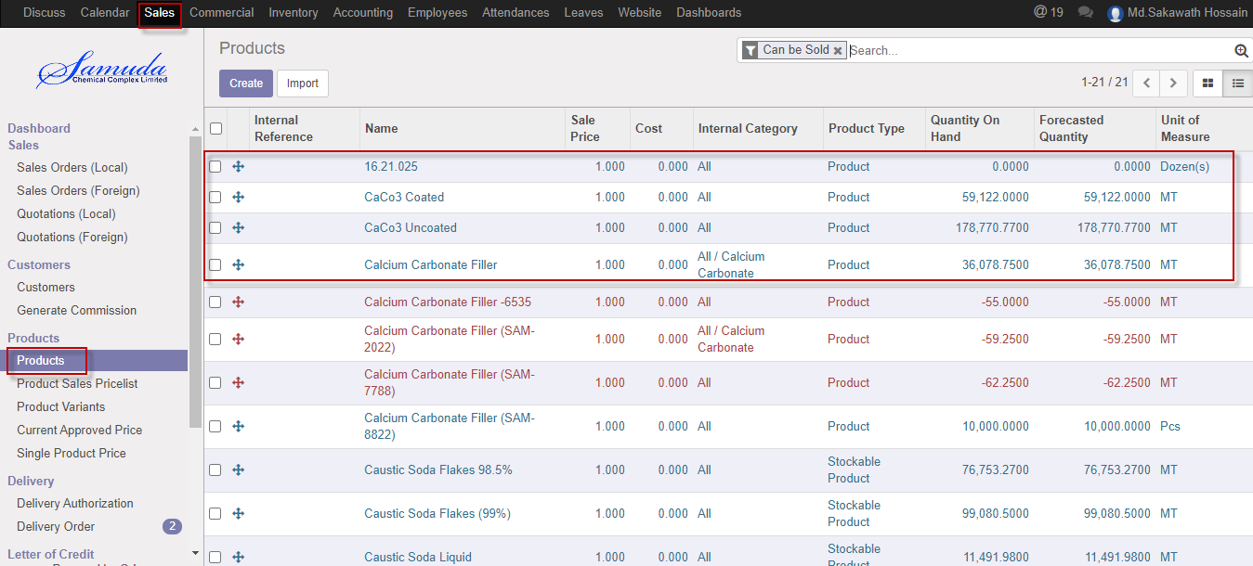

Figure: Products List view

We need to set the following:-

**Product name**: Enter a product name.

**Product type**: Enter a product type.

**Internal reference:** Select internal reference.

**Internal category:** Select internal category.

**H.S code:** Select H.S code.

**Country of Origin:** Select country of origin.

**TDS rule:** Select TDS rule.

**Company:** select Company.

**Commission type:** Select commission type.

**Unit of Measure:** Select unit of measure.

**Can be sold:** Checked.

**Can be purchased:** Unchecked.

**Product variants:** Variants of products should be set using this tab.

**UoM:** Set UoM as MT.

After entering all information click **Save**.

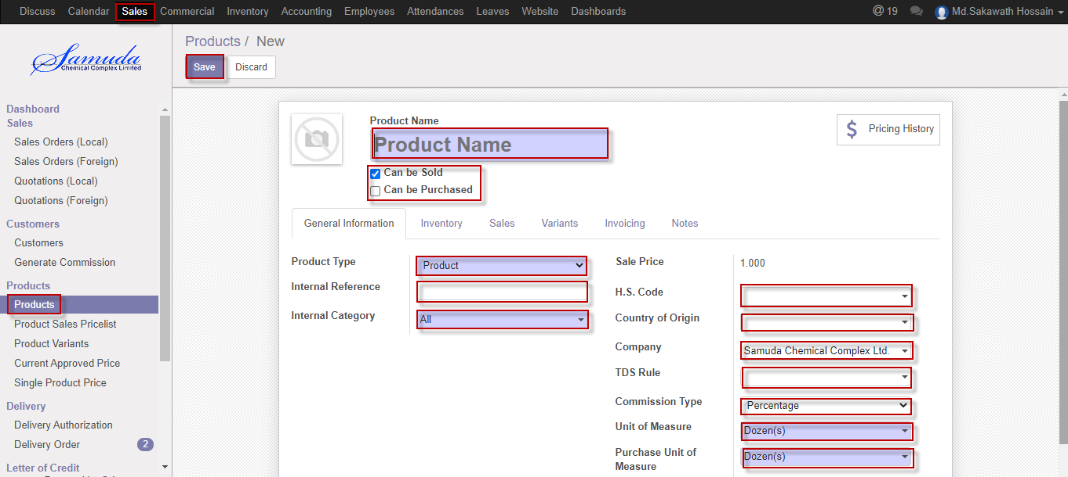

Figure: Create a products

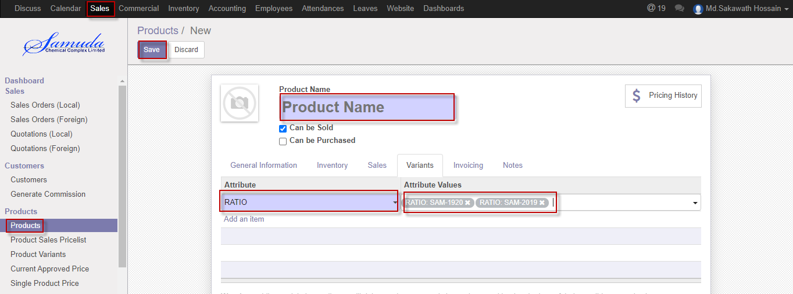

Figure: Create a variants.

# 4. Customer credit limit

Customer credit limit is the maximum amount of credit that a financial institution or other lender will extend to a debtor for a particular line of credit (sometimes called a credit line, line of credit, or a trade line.

If exceed credit limit during Sales order then Second level approval require.

If (Receivable amount +sales order amount) is greater than credit limit then will go second level approval.

## 4.1 Create customer credit limit by Sales Executive/Head of sales

Sales Executive will be created/Edit by customer credit limit.

We can create Customer using the menu **sales ‣ Customer credit limit** and click **Create.**

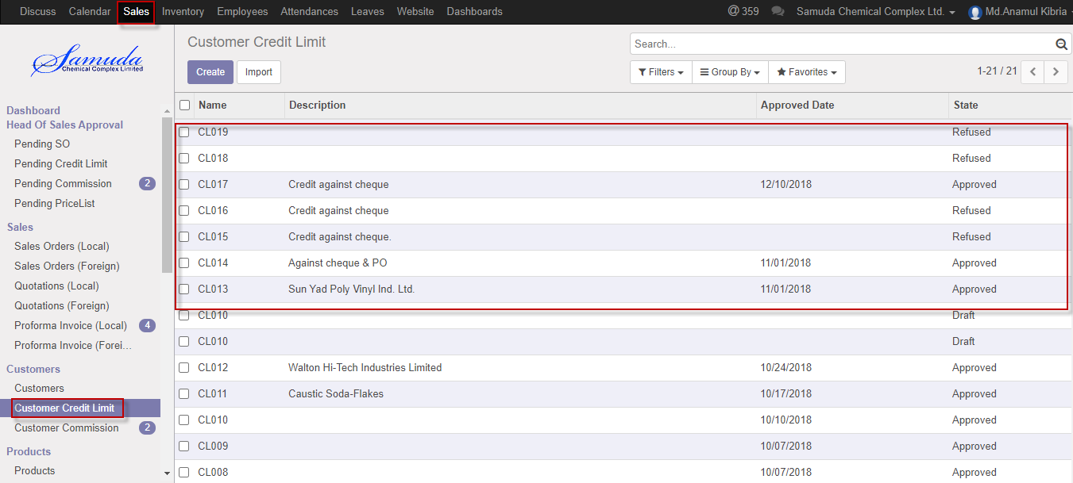

Figure: Customer credit limit List view

We need to set the following:-

**Description**: Enter a description.

**Credit limit**: Enter credit limit.

**Days:** Enter days.

**Customer:** Select customer.

**Confirm:** press Confirm button.

After entering all information click **Save**.

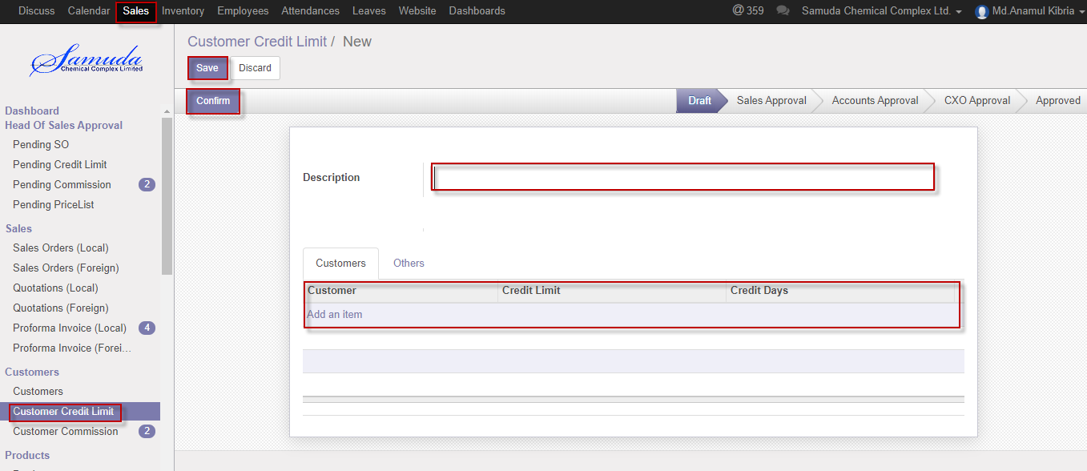

Figure: Create customer credit limit

## 4.2 Customer credit limit approval by Head of Sales

After apply the customer Credit limit head of sales will get the notification. He/she can update limit before approval.

To see the customer credit limit request use the menu **Sales ‣ Customer credit limit**

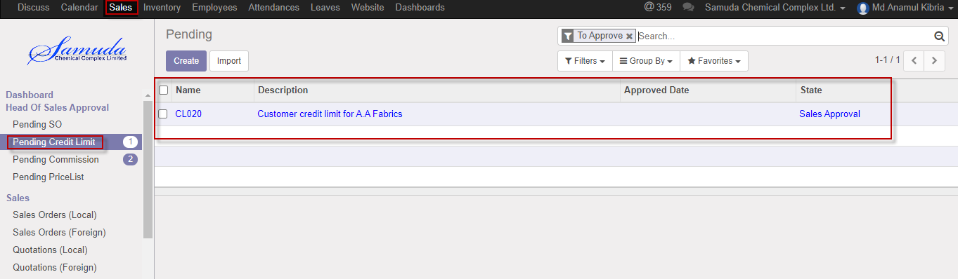

Figure: Customer credit limit head of sales approval list view

Head of Sales can approve customer credit limit. Head of sales approve the request by click on **Approve** button 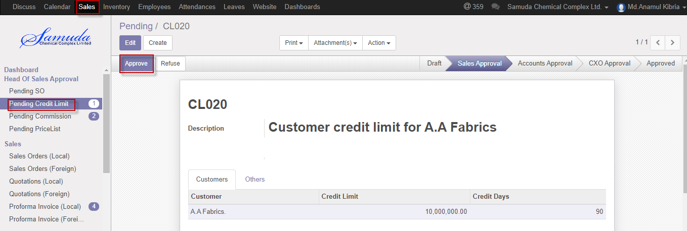

Figure: Customer credit limit head of sales approval

Head of sales can refuse customer credit limit by click **Refuse** Button.

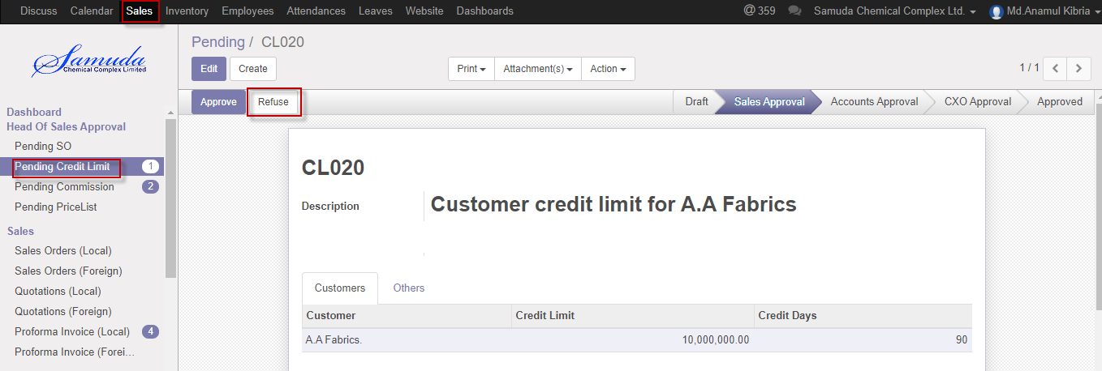Figure: Customer credit limit Refuse

## 4.3 Customer credit limit Validate by Head of accounts

After approve the customer Credit limit by head of sales, head of accounts will get the notification. He/she can validate/refuse the customer credit limit.

To see the customer credit limit request use the menu **Sales ‣ Customer credit limit**

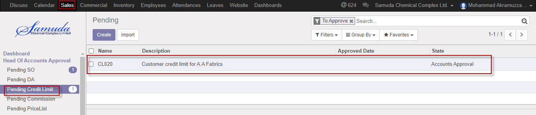

Figure: Customer credit limit head of accounts list view

Head of accounts can validate customer credit limit. Head of accounts approve the request by click on **Validate** button 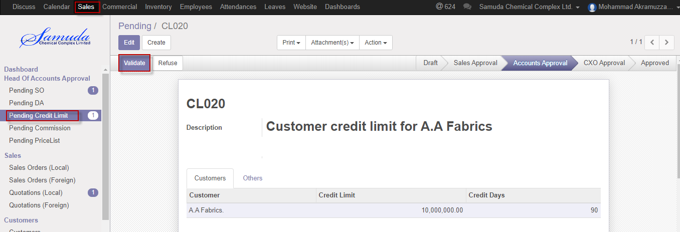

Figure: Customer credit limit Validate by head of accounts

Head of accounts can refuse customer credit limit by click **Refuse** Button.

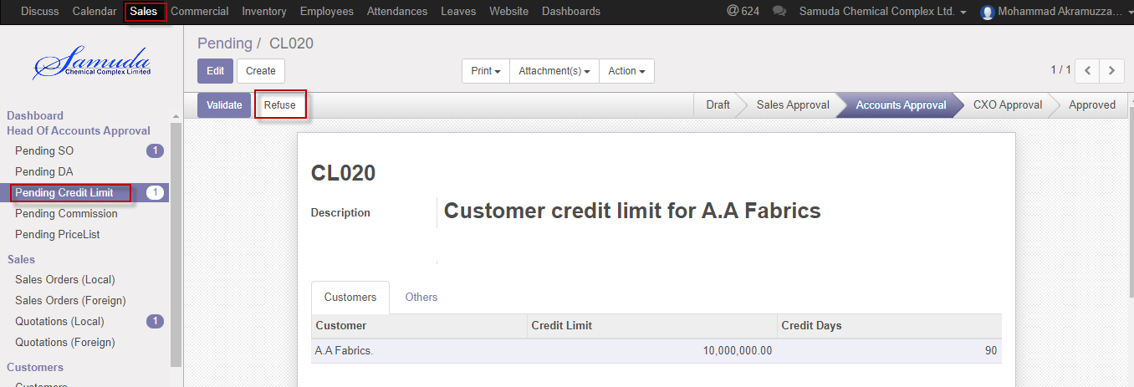 Figure: Customercredit limit head of accounts refuse

## 4.4 Customer credit limit approve by CXO

After approve the customer Credit limit by head of accounts, CXO will get the notification. He/she can approve the customer credit limit.

To see the customer credit limit request use the menu **Sales ‣ Customer credit limit**

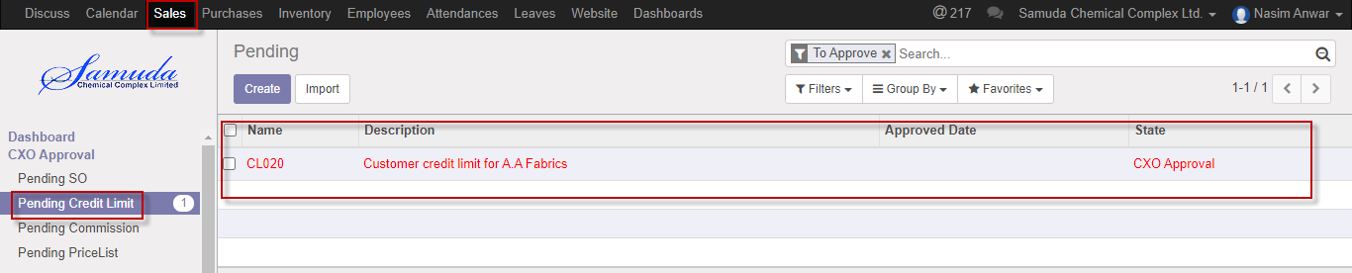

Figure: Customer credit limit list view

CXO can approve customer credit limit. CXO approve the request by click on **Approve** button 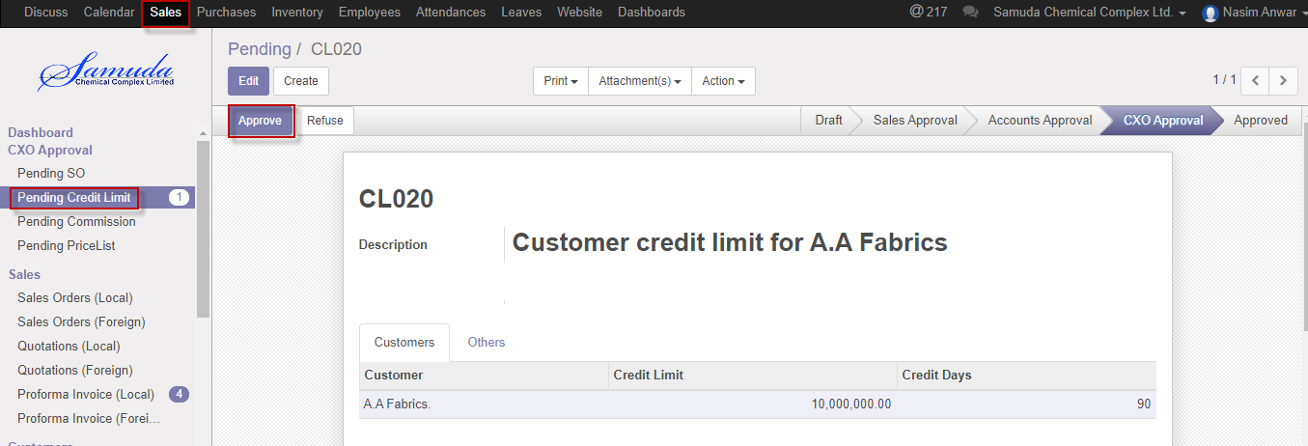

Figure: Customer credit limit CXO Approval

CXO can refuse customer credit limit by click **Refuse** Button.

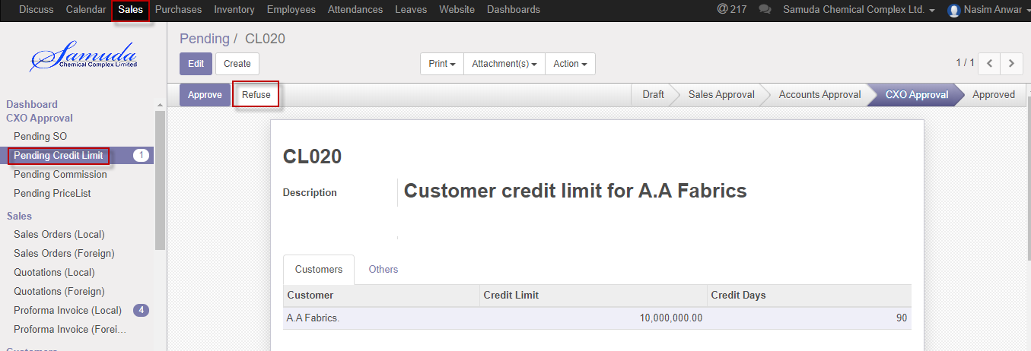 Figure: Customercredit limit Refuse

# 5. Customer Commission

Customer commission request will be initiated by Sales department for example Sales Executive/Head of Sales. It will then wait for the first level approval from Head of Accounts. After the first level approval it will then wait for the second/final level of approval from Management. The request can be rejected from both the approval layers. Customer commission will be set by two types Percentage wise and State value. Commission type if customer then will be percentage wise. And if by product then will be state value.

## 5.1 Create customer commission by Sales executive/Head of sales

Customer commission will be created/Edit by Sales executive/Head of sales

We can create customer commission using the menu **Sales ‣ Customer commission** and click **Create.**

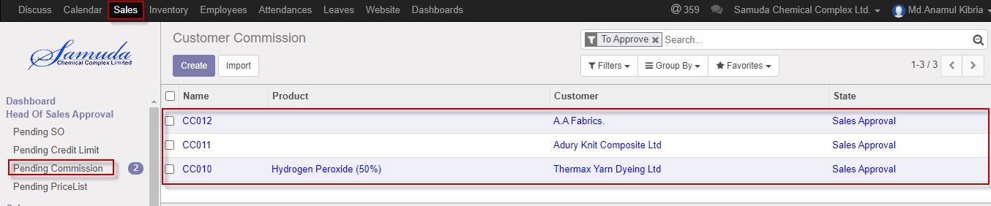

Figure: Customer commission List view

We need to set the following:-

**Commission type**: Select commission type.

**Product:** Select product.

**Customer:** Select customer.

**Value:** Enter new value.

After entering all information click **Save & confirm**.

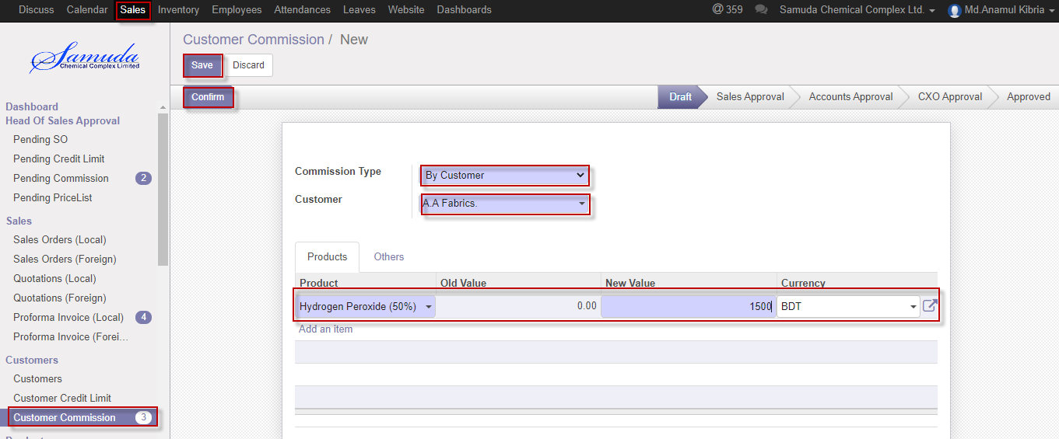

Figure: Create customer commission

## 5.2 Customer commission approval by Head of Sales

After apply the customer commission head of Sales will get the notification. He/she can update commission before approval.

To see the customer commission request use the menu **Sales ‣ Customer commission**



Figure: Customer commission list view

Head of sales can approve customer commission. Head of sales approve the request by click on **Approve** button 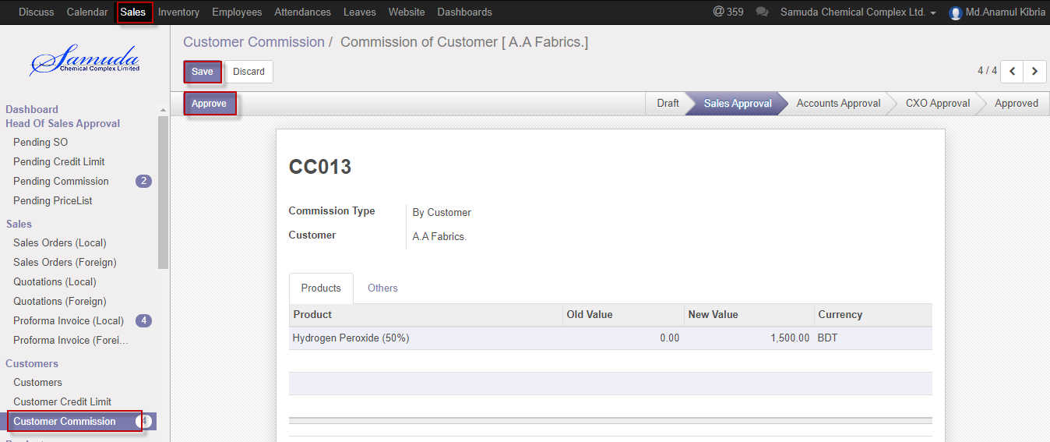

Figure: Customer commission head of sales approval

## 5.3 Customer commission Validate by Head of accounts

After approve the customer commission by head of sales, head of accounts will get the notification. He/she can validate/refuse the customer commission.

To see the customer commission request use the menu **Sales ‣ Customer commission**

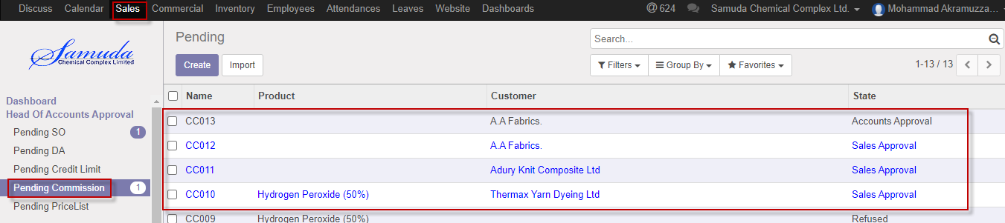

Figure: Customer commission head of accounts list view

Head of accounts can validate customer commission. Head of accounts validate the request by click on **Validate** button 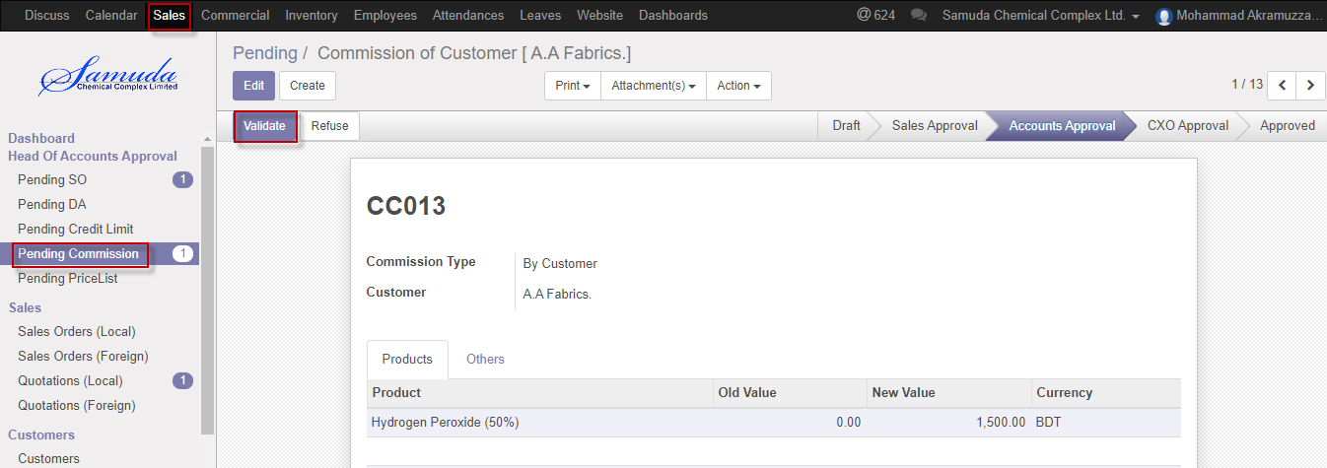

Figure: Customer commission head of accounts Validate

Head of accounts can refuse customer commission by click **Refuse** Button.

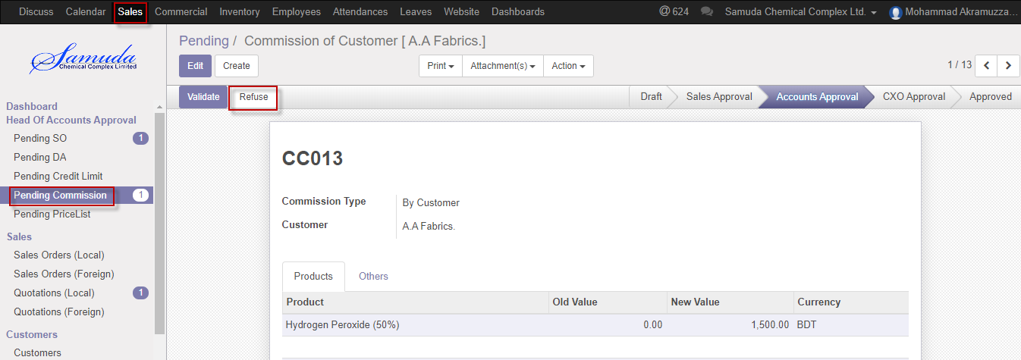 Figure: Customercommission Refuse

## 5.4 Customer commission approval by CXO

After approve the customer commission by head of accounts, CXO will get the notification. He/she can approve the Customer commission.

To see the customer commission request use the menu **Sales ‣ Customer commission**

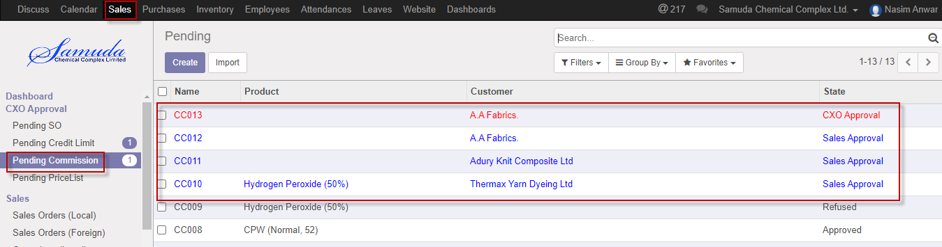

Figure: Customer commission list view

CXO can approve customer commission. CXO approve the request by click on **Approve** button 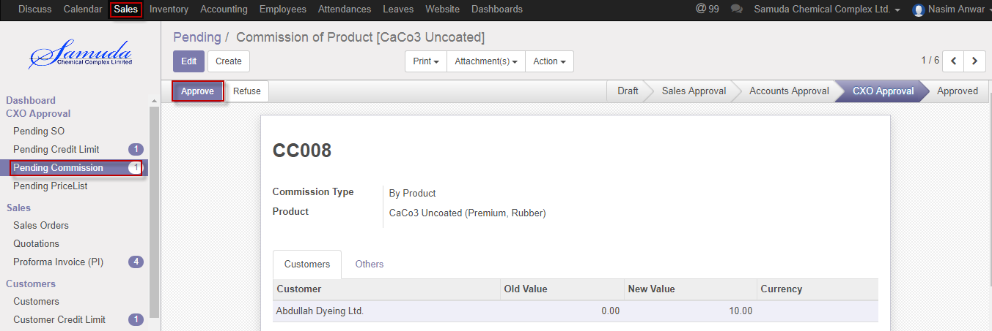

Figure: Customer commission CXO approval

CXO can refuse customer commission by click **Refuse** Button.

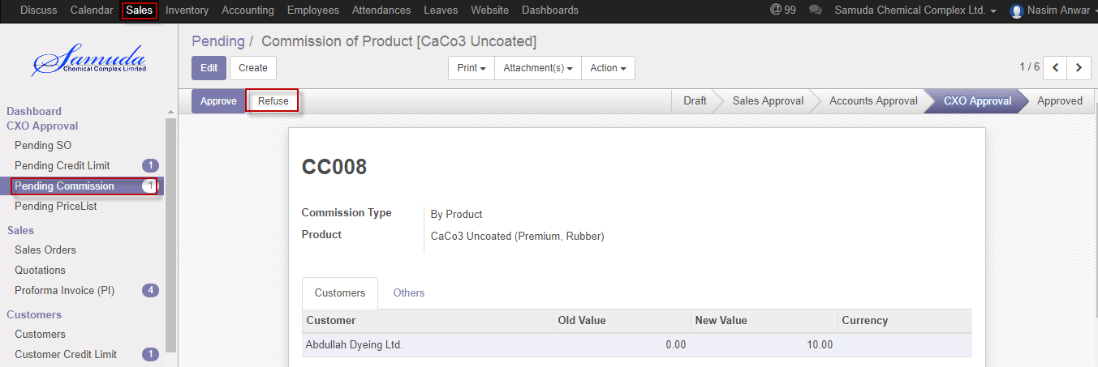 Figure: Customercommission CXO Refuse

# 6. Product Sales Pricelist

This form will introduce new product price replacing the old product price. Management user can be able to change product price & last new price should be countable & old price should have always read only. Latest price will show in product.

Product, packing mode, Ou & Currency wise will calculate in Quotation or Sales order form.

## 6.1 Create product sales pricelist by Sales executive/Head of sales

Product sales pricelist will be created/Edit by Sales executive

We can create product sales pricelist using the menu **Sales ‣ Products>>Product sales pricelist** and click **Create.**

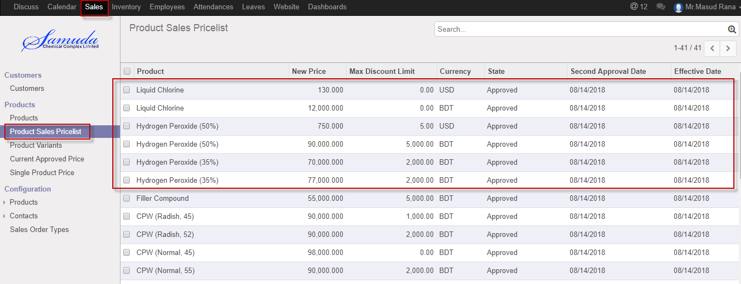

Figure: Product sales pricelist List view

We need to set the following:-

**Product**: Select product.

**Packaging Mode:** Select packaging mode.

**Ou:** Select Ou.

**Currency:** Select currency.

**New price:** Enter new price.

**Effective date:** Select effective date.

After entering all information click **Save & confirm**.

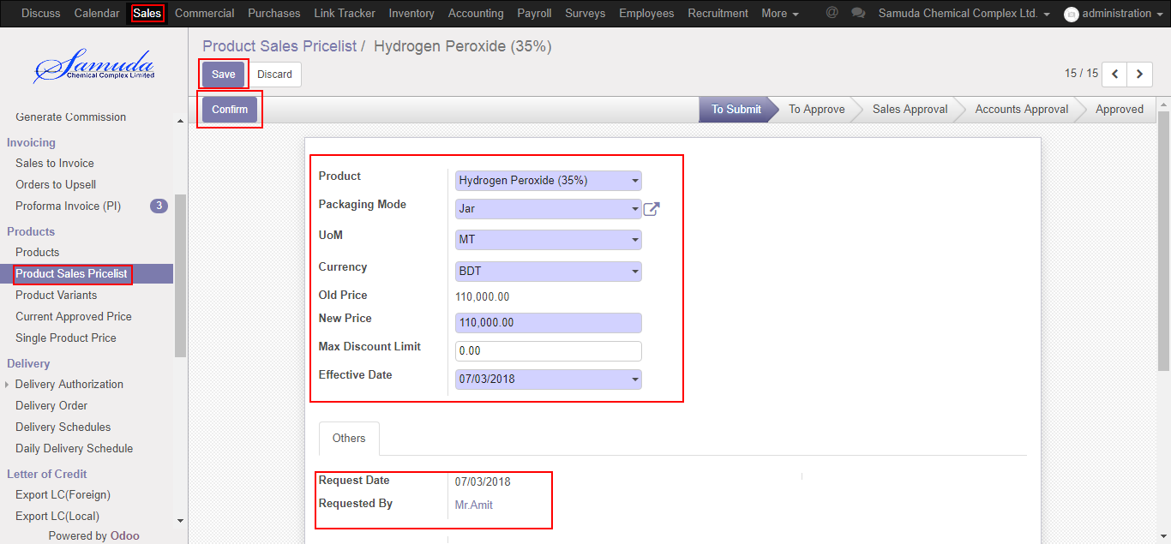

Figure: Create product sales pricelist

## 6.2 Product sales pricelist Approve by head of sales

After confirmation the product sales pricelist head of sales will get the notification. He/she can approve sales price.

To see the product sales pricelist request use the menu **Sales ‣ Products>>Product sales pricelist**

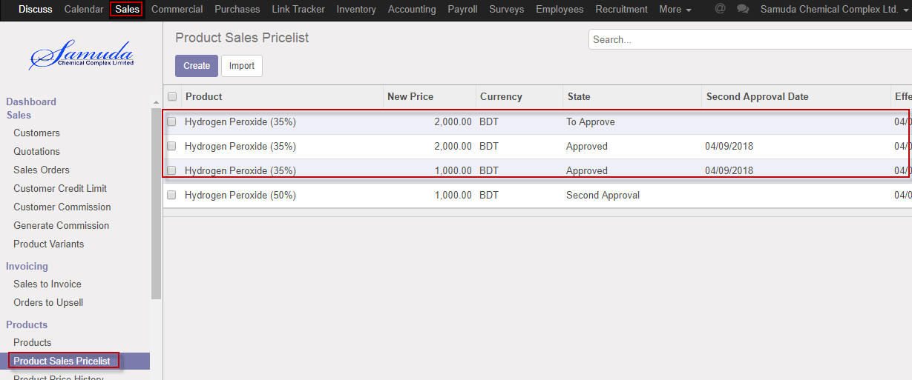

Figure: Product sales pricelist list view

Head of sales can approve product sales pricelist. Head of sales approve the request by click on **Approve** button 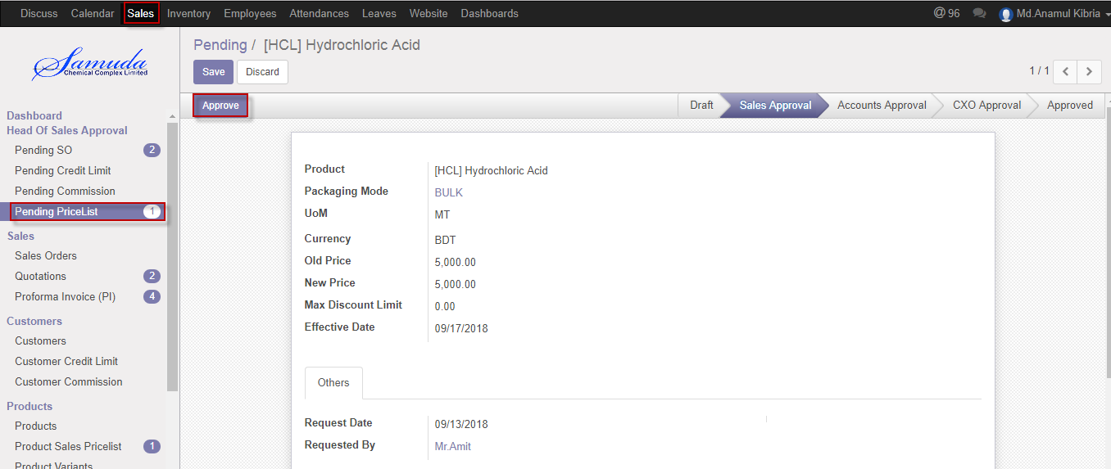

Figure: Sales pricelist Approve

## 6.3 Product sales pricelist Validate by Head of accounts

After approve the Product sales pricelist by head of sales, head of accounts will get the notification. He/she can validate/refuse the customer commission.

To see the Product sales pricelist request use the menu **Sales ‣ Product sales pricelist**

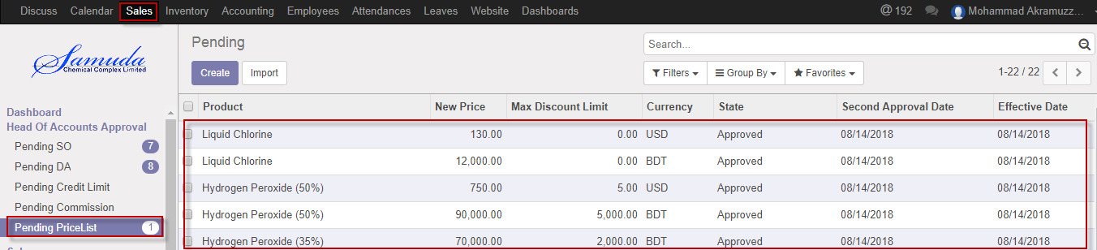

Figure: Product sales pricelist list view

Head of accounts can validate Product sales pricelist. Head of accounts validate the request by click on **Validate** button 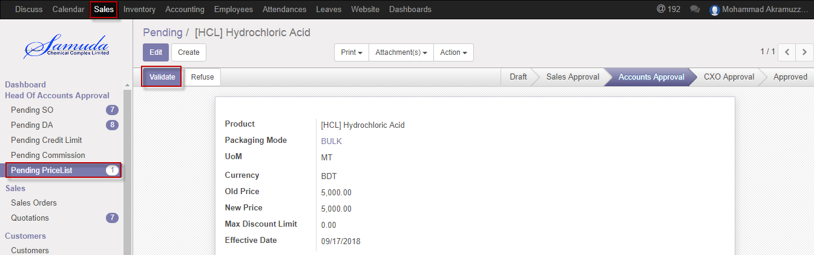

Figure: Product sales pricelist Validate

Head of accounts can refuse Product sales pricelist by click **Refuse** Button.

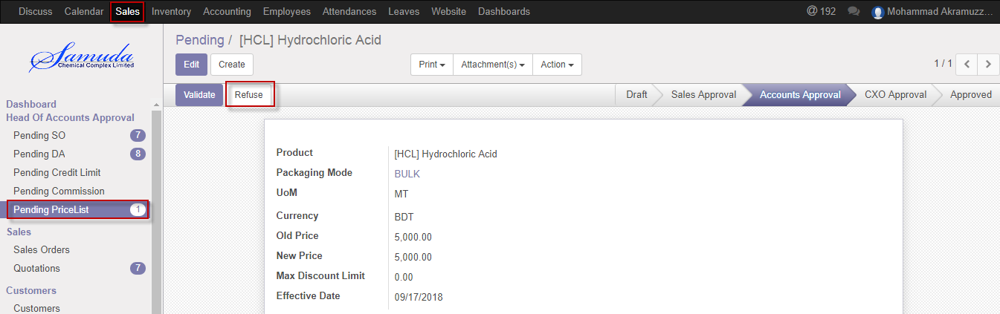 Figure: Product sales pricelist Refuse

## 6.4 Product sales pricelist Approve by CXO

After Validate the product sales pricelist head of accounts, CXO will get the notification. He/she can approve sales price.

To see the product sales pricelist request use the menu **Sales ‣ Products>>Product sales pricelist**



Figure: Product sales pricelist list view

CXO can approve product sales pricelist. CXO can approve the request by click on **Approve** button 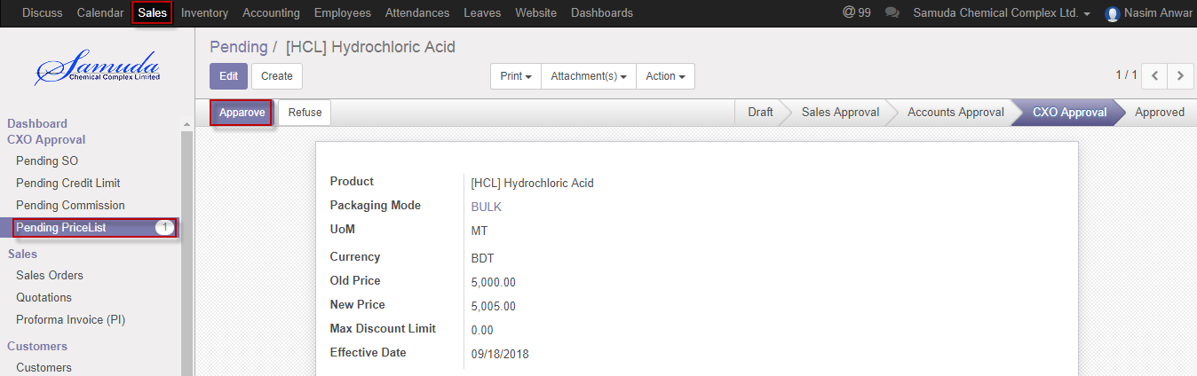

Figure: Sales pricelist Approve

CXO can refuse Product sales pricelist by click **Refuse** Button.

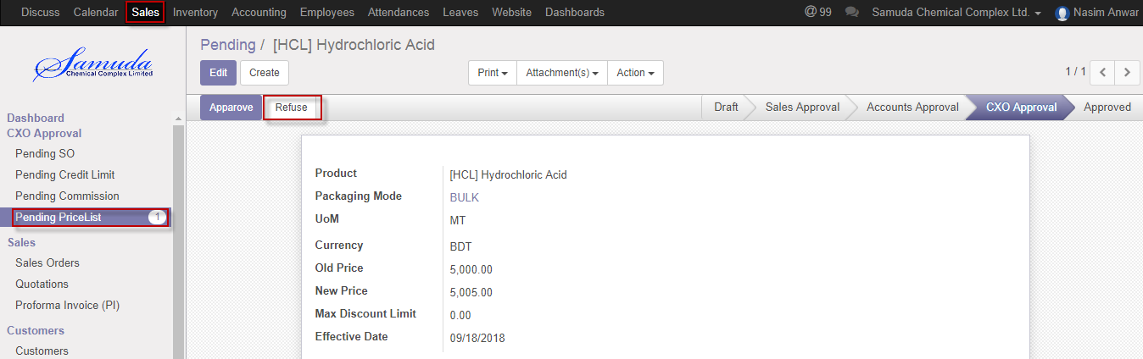 Figure: Product sales pricelist Refuse

# 7. Variant history

Everyday 6pm will auto update a scheduler then latest product price history will come auto. Product prices will be automatically updated by a schedules every day at 6PM.

## 7.1 Variant history view by Sales user

These prices will be loaded when a sales order is created.

We can view Variant history using the menu **Sales ‣Current Approved Price**

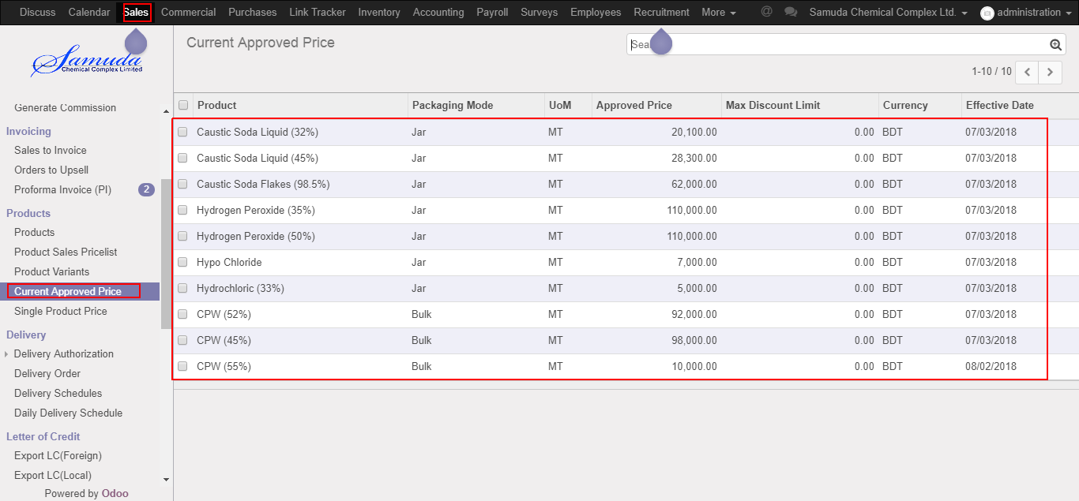

Figure: Variant history view

# 8. Generate commission

Accounts user will generate commission. After generate commission Customer will get commission up to date.

## 8.1 Create Generate commission by Accounts executive/Head of accounts

Generate commission will be created/Edit by Accounts executive/Head of accounts

We can create Generate commission using the menu **Sales ‣ Customer>>Generate commission** and click **Create.**

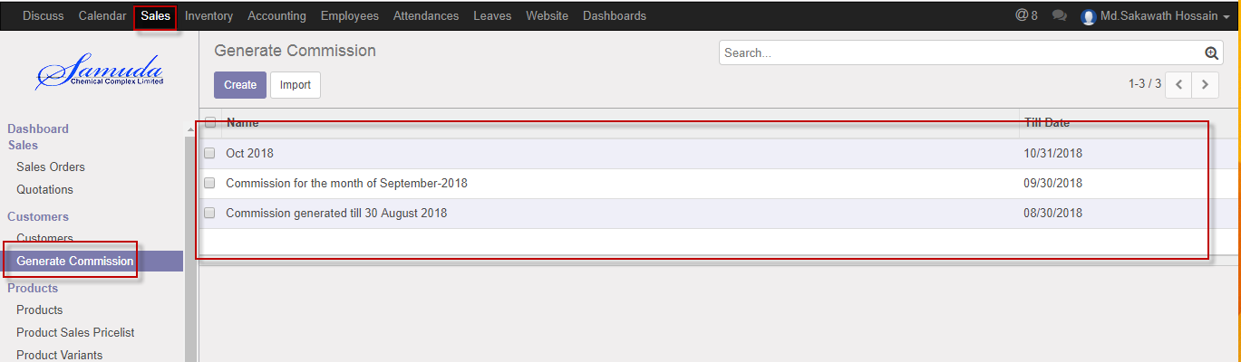

Figure: Generate commission List view

We need to set the following:-

**Title**: Enter a commission title name.

**Till date:** Select a date.

**Customer:** Customer will come auto after click generate button.

**Invoiced amount:** Invoice amount will come auto after click generate button.

**Commission amount:** Commission amount will come auto after click generate button.

After entering all information click **Generate & Save** button.

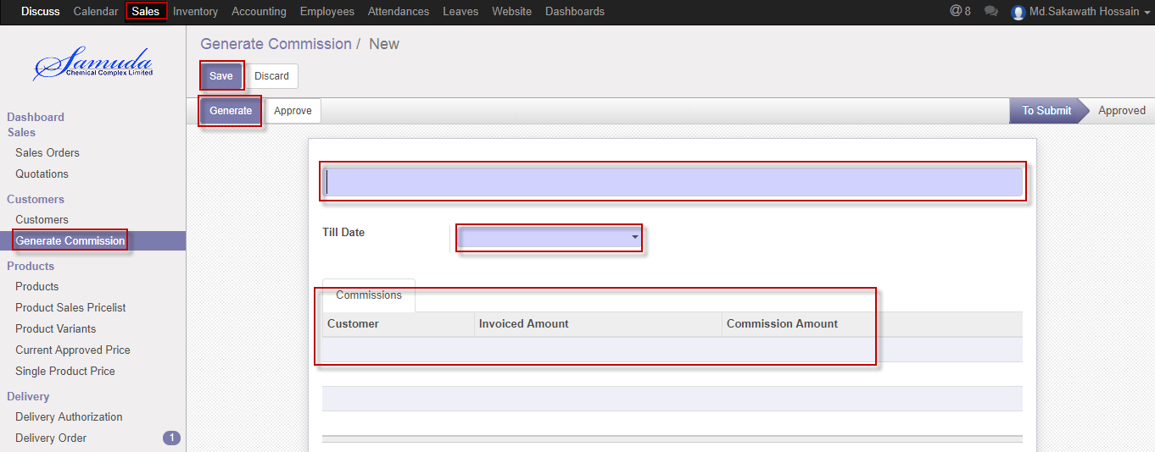

Figure: Create Generate commission

## 8.2 Generate commission Approve by Accounts executive/Head of accounts

To see the Generate commission use the menu **Sales ‣ Customer >>Generate commission**



Figure: Generate commission list view

Accounts executive/Head of accounts can approve generate commission. Accounts executive/Head of accounts can approve the request by click on **Approve** button 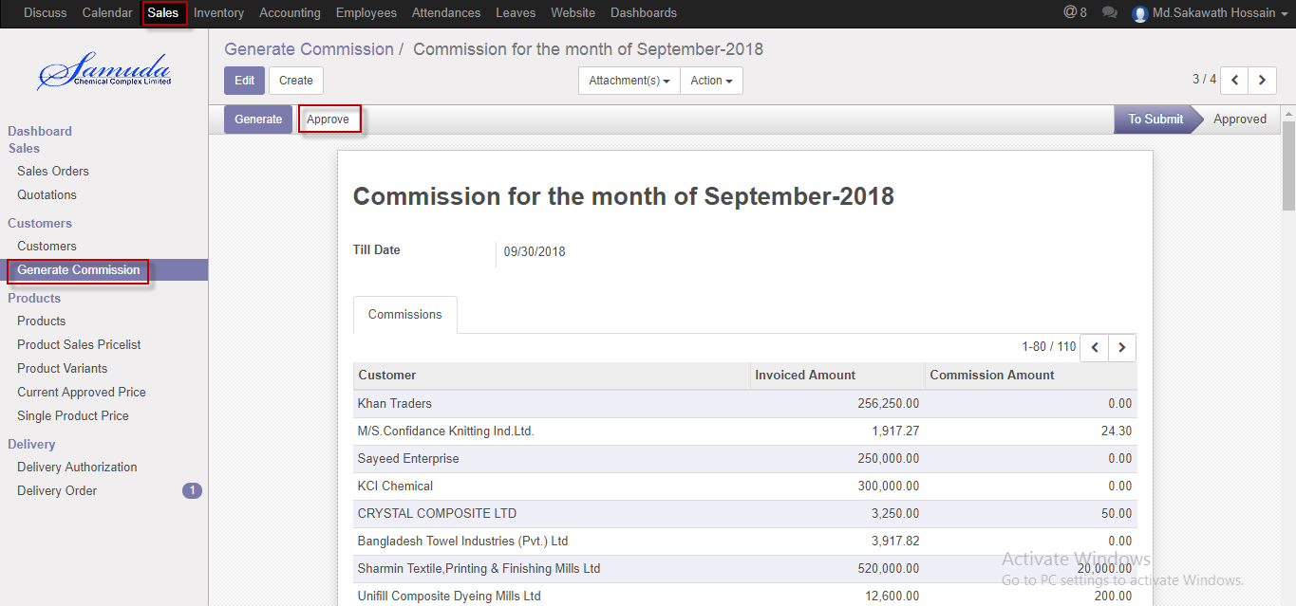

Figure: Generate commission Approve

# 9. Proforma Invoice (Local)

## 9.1 Create Proforma Invoice by Local Sales executive

We can view Proforma Invoice using the menu **Sales ‣** **Proforma Invoice**

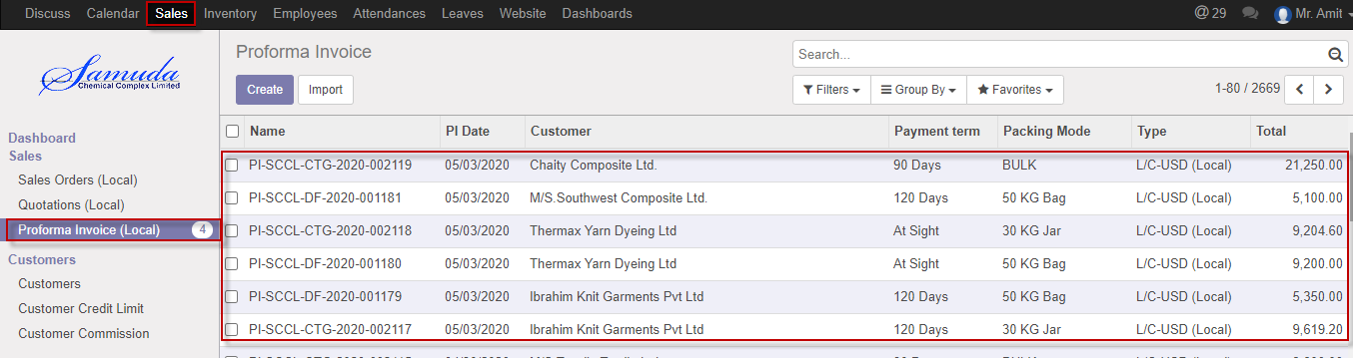

Figure: Proforma Invoice local list view

We need to set the following:-

**Beneficiary**: Select beneficiary.

**PI date:** Select PI date.

**Advising Bank Acc:** Select advising Bank.

**Payment term:** Select a payment term from list box.

**Transport By:** Enter a transport name.

**Terms of Delivery:** Enter terms of delivery.

**Customer:** Select Customer.

**Customer address:** Customer address will come auto after select customer.

**Packing Mode:** Select a packing mode from select box.

**Type:** Select a transaction type from dropdown, transaction type should only LC- BDT(Local) for local PI.

**Operating Unit:** Select an operating unit.

After entering all information click **Save & Confirm**

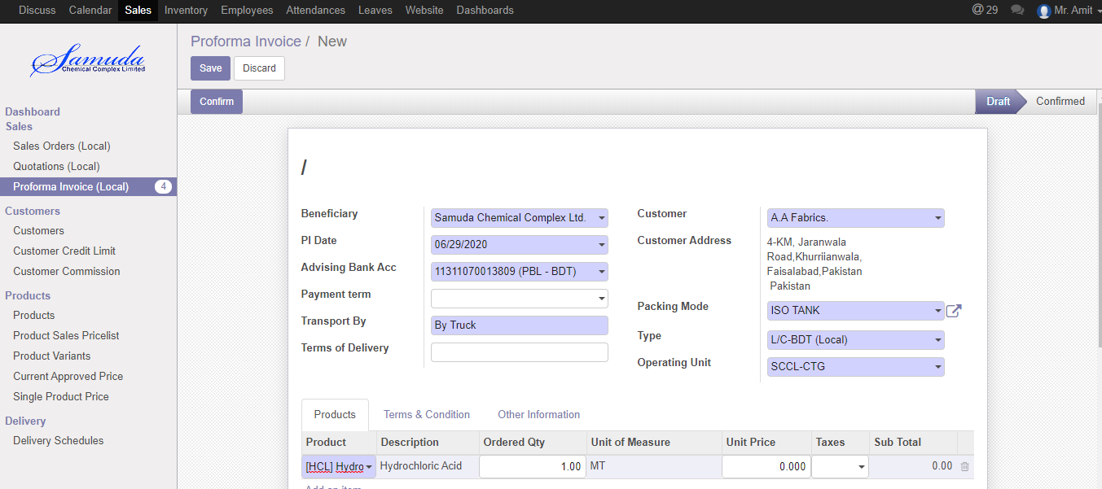

Figure: Create Local Proforma Invoice

# 10. Proforma Invoice (Foreign)

## 10.1 Create Proforma Invoice by Foreign Sales executive

We can view Proforma Invoice using the menu **Sales ‣** **Proforma Invoice**

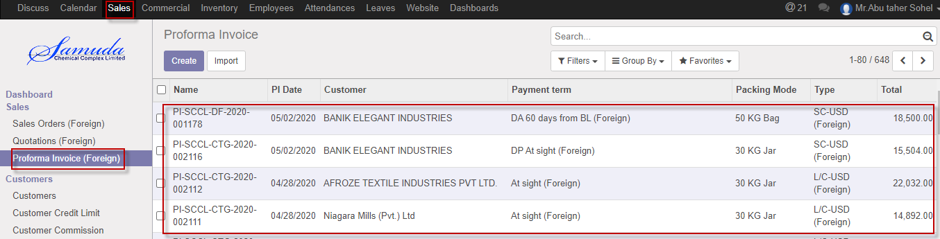

Figure: Foreign Proforma Invoice List view

We need to set the following:-

**Beneficiary**: Select beneficiary.

**PI date:** Select PI date.

**Advising Bank Acc:** Select advising Bank.

**Payment term:** Select a payment term from list box.

**Transport By:** Enter a transport name.

**Terms of Delivery:** Enter terms of delivery.

**Customer:** Select Customer.

**Customer address:** Customer address will come auto after select customer.

**Packing Mode:** Select a packing mode from select box.

**Type:** Select a transaction type from dropdown, Various type of foreign transaction existing like LC-USD,TT-USD etc.

**Operating Unit:** Select an operating unit.

After entering all information click **Save & Confirm**

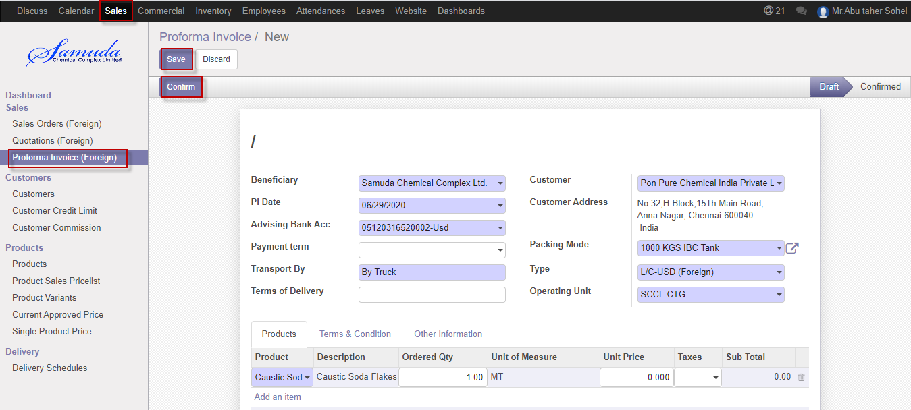

Figure: Create Foreign Proforma Invoice

# 11. Quotation (Local)

The process start from getting an order request from a customer to sales executive. Based on the business nature, Samuda practices four types of Sales Order. This four types of sales order will be created from Sales order type form.

1. Cash

2. Credit Sales

3. LC

4. TT

## 11.1 Create Quotation local by Sales executive

Quotation will be created/Edit by Sales executive

Quotation will create With PI and without PI.

We can create sales order using the menu **Sales ‣ Quotation** and click **Create.**

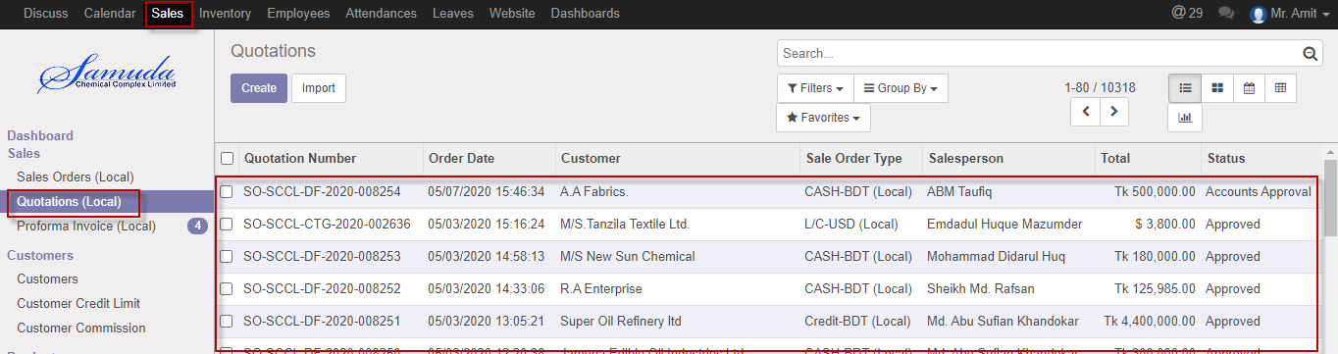

Figure: Quotation Local List view

We need to set the following:-

**Customer**: Customer will come auto after select PI.

**Invoice Address**: Invoice address will come auto after select PI

**Delivery Address**: Delivery address will come auto after select PI.

**Delivery mode**: Select delivery mode from dropdown.

**Is Vat Applicable**: Select vat applicable from radio button.

**Is Bonded Applicable**: Select from radio button.

**Order date:** Select order date.

**Expiration date:** Select expiration date.

**Type:** Select transaction type.

**Packing mode:** Select packing mode.

**Sales Channel:** Select sales channel.

**PI Ref.** NO: Select PI ref. No.

**Order line:** Add order line.

**Payment Terms:** Select Payment terms.

**Region Type:** Region type will come auto after select PI.

After entering all information click **Save & Submit**.

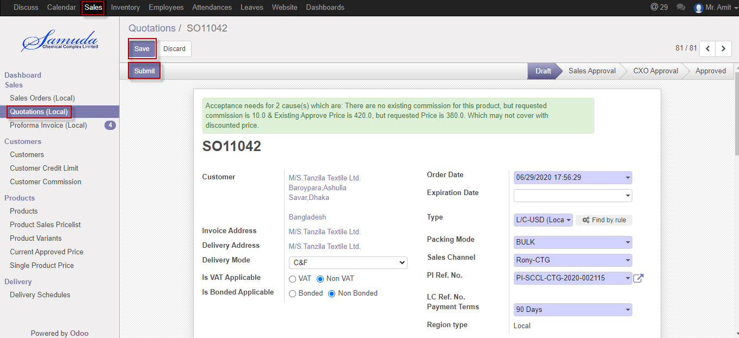

Figure: Create Quotation

## 11.2 Quotation approval by head of sales

Head of sales will approve first approval. If unit price & commission no change then it will done state. Otherwise it will go accounts approval. Head of account will show notification top of the form his/her own window.

If unit price or commission change then it will go for Management approval.

After apply the sales order head of sales will get the notification. He/she can update before approve.

To see the sales order request use the menu **Sales ‣ Pending SO**

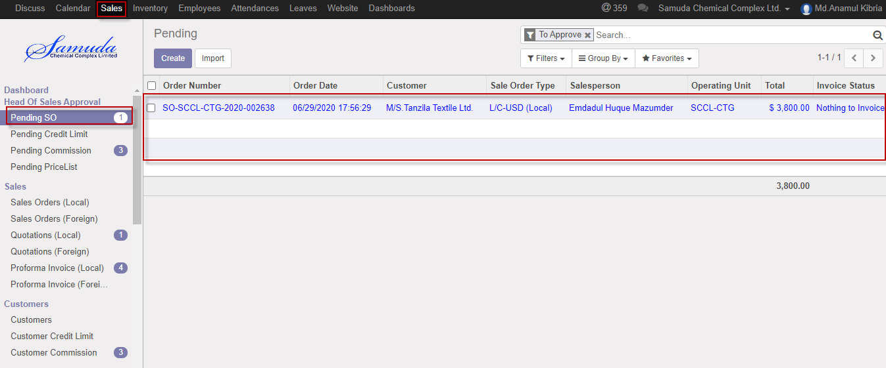

Figure: Quotation list view for Head of sales

Head of sales can confirm Quotation. Head of sales confirm the request by click on **Confirm** button & He/she can also capable to Reset to Draft.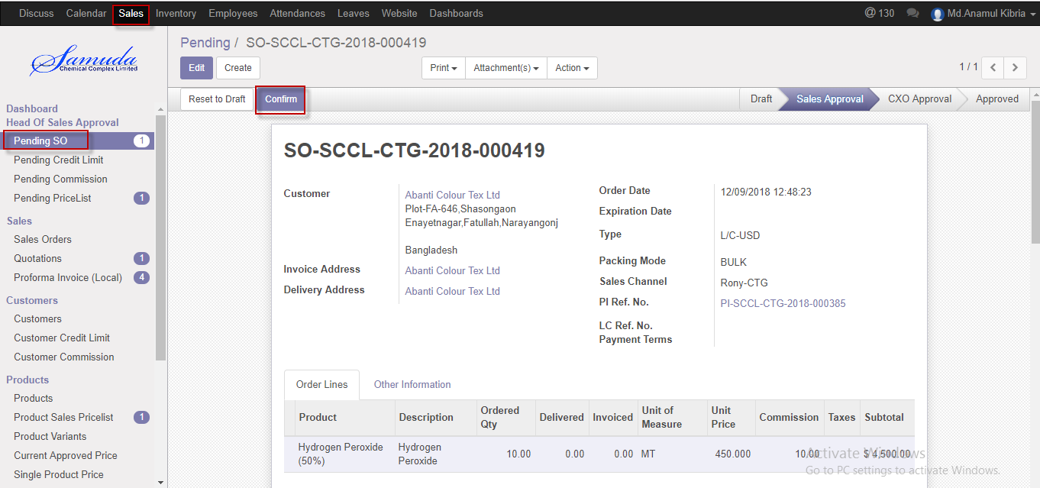

Figure: Quotation confirmed for Head of Sales

## 11.3 Quotation validate by head of account

After creation of SO, system will check the summation of Sales Order amount, Customer's Receivable amount, and total undelivered DO qty amount for that customer, total unposted invoiced amount for that customer with Customer's Credit Limit. If positive then there is no need of Second Approval for this case and Head of Sales can give final approval of Sales Order.

After confirmation the Quotation head of account will get the notification. He/she can capable to update before approve.

To see the Quotation request use the menu **Sales ‣ Pending SO**

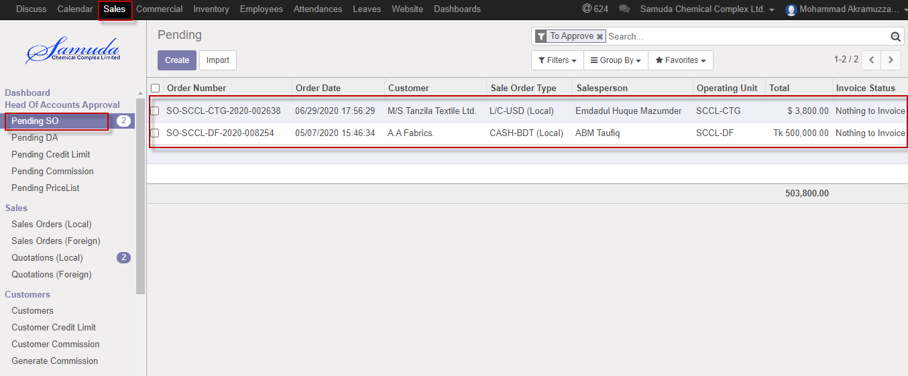

Figure: Quotation list view for Head of accounts

Head of account can validate Quotation. Head of account validate the request by click on **Validate** button 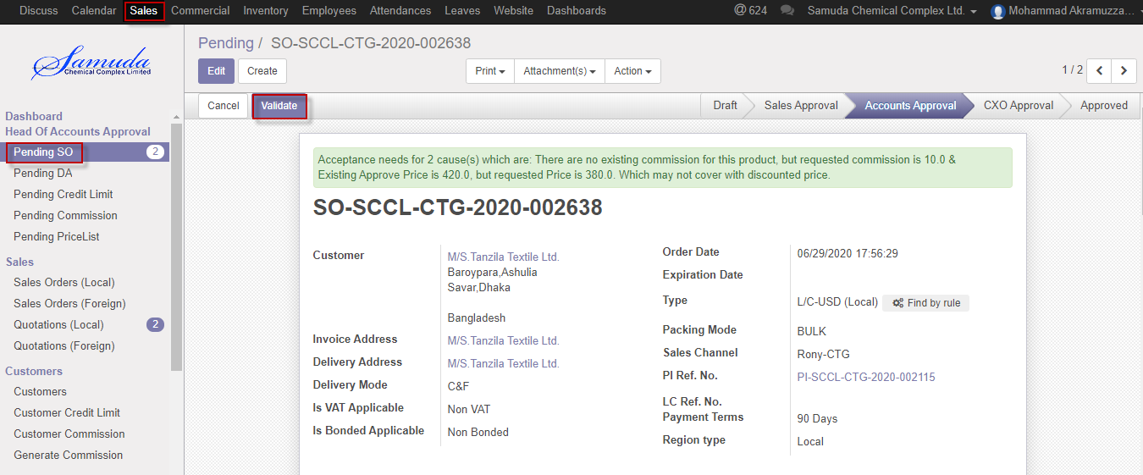

Figure: Quotation Validate

Head of account can able to Cancel Quotation. Head of account cancel the request by click on **Cancel** button 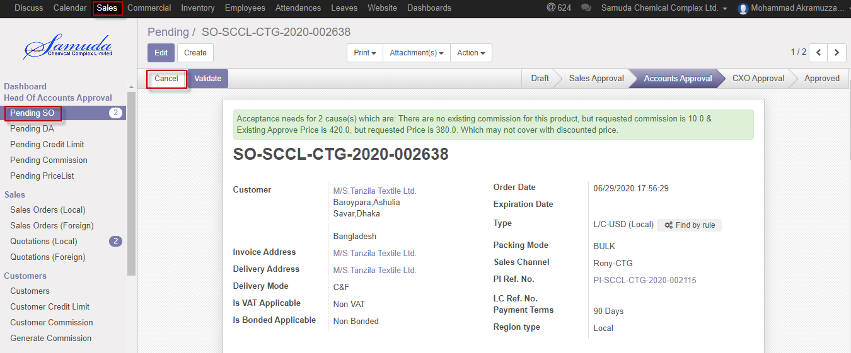

Figure: Quotation Cancel

## 11.4 Quotation approve by CXO

Quotation will go CXO/Director state if Quotation amount, Customer's Receivable amount, and total undelivered DO qty amount for that customer is bigger than credit limit.

After validate the Quotation CXO will get the notification. He/she can update or cancel before approve.

To see the sales order request use the menu **Sales ‣ Pending SO**

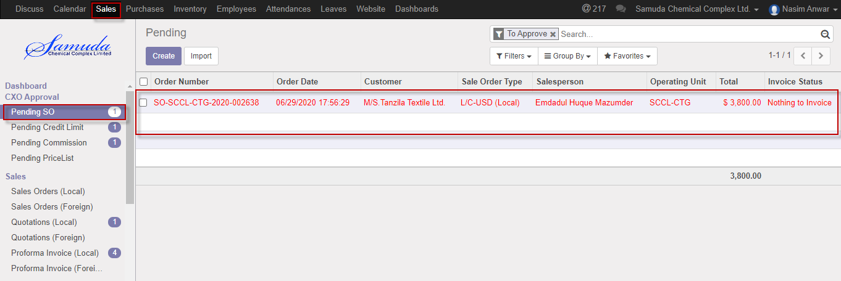

Figure: Quotation list view for CXO

CXO can approve Quotation. CXO approve the request by click on **Approve** button 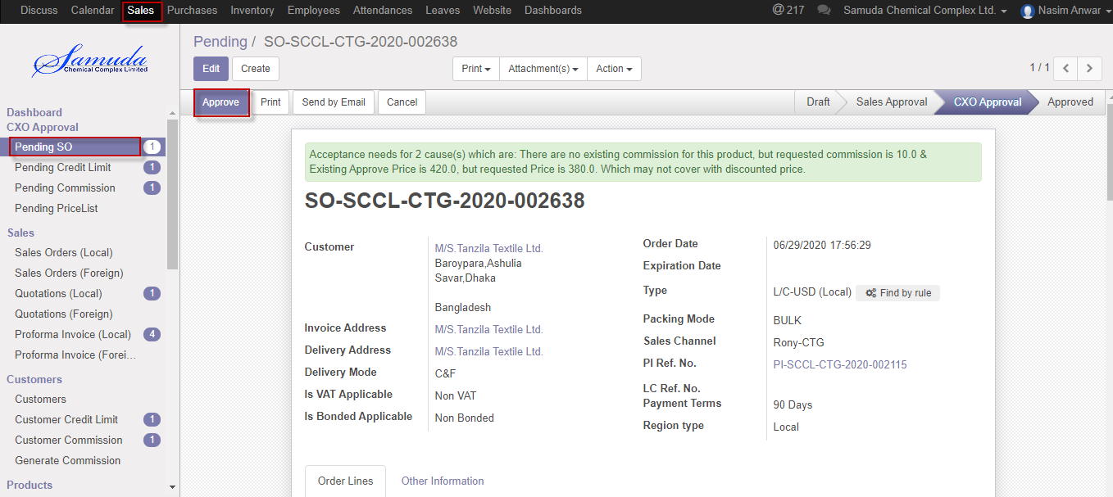

Figure: Quotation approve for CXO

Head of account & CXO is capable to cancel Quotation by click **Cancel** Button.

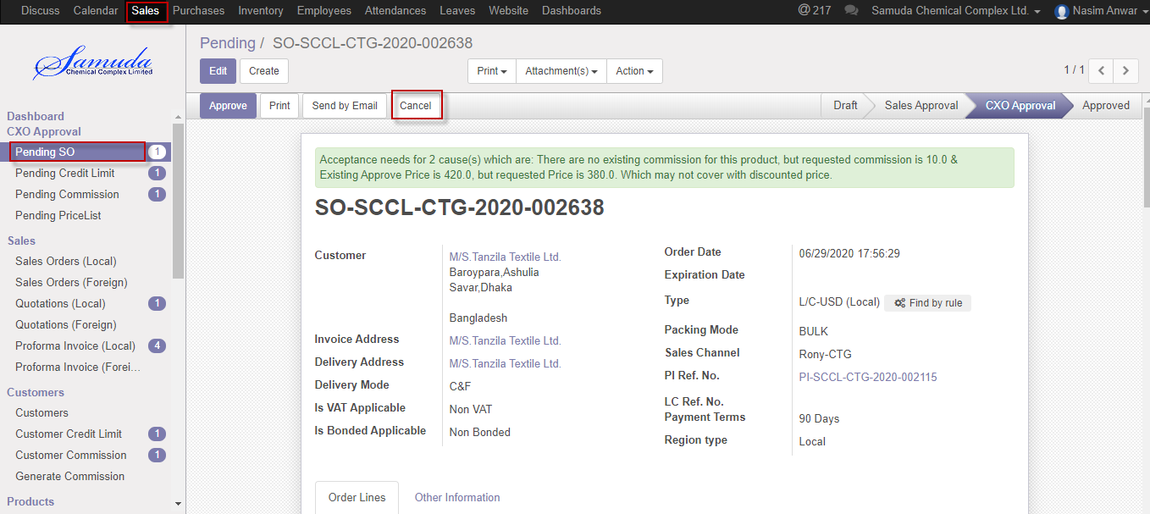

Figure: Sales order cancel

# 12. Sales Order (Local) View

Quotation will treat as a Sales order after all approval of Quotation. Approve sales order will go for Delivery authorization approval.

## 12.1 View Sales order by Sales User

Sales User will view the sales order using the menu **Sales ‣Sales> Sales Order (Local)** and click for View.

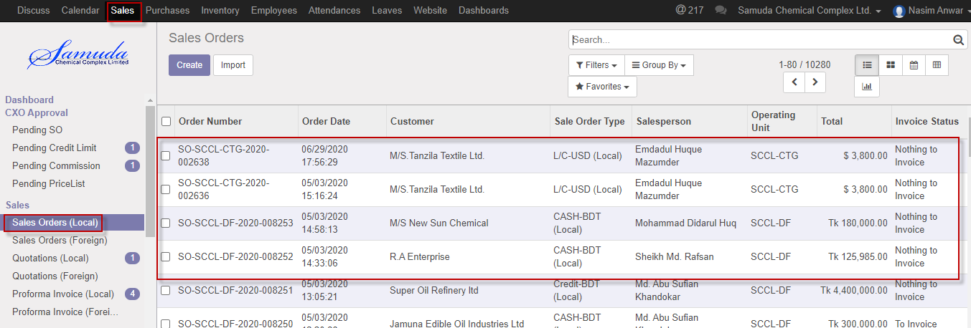

Figure: Sales Order Local List view

# 13. Quotation (Foreign)

The process start from getting an order request from a customer to sales executive. Based on the business nature, Samuda practices three types of Sales Order for foreign sales. This three types of sales order will be created from Sales order type form.

1. Credit Sales

2. LC

3. TT

## 13.1 Create Quotation Foreign by Sales executive

Quotation will be created/Edit by Sales executive

Quotation will create With PI and without PI.

We can create sales order using the menu **Sales ‣ Quotation** and click **Create.**

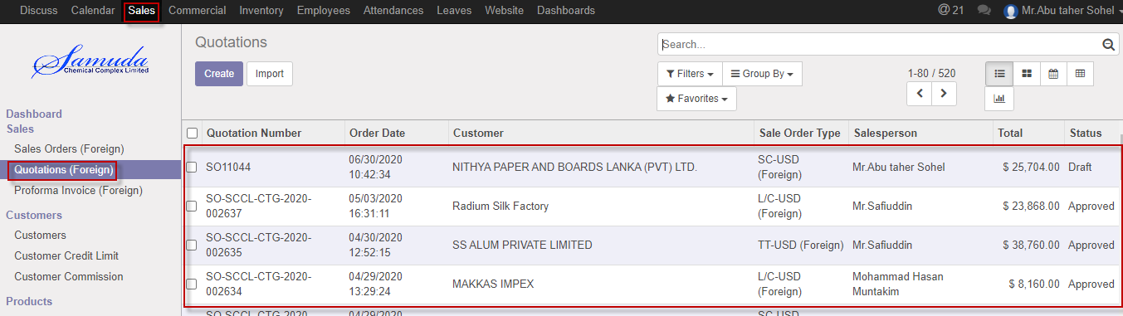

Figure: Quotation Foreign List view

We need to set the following:-

**Customer**: Customer will come auto after select PI.

**Invoice Address**: Invoice address will come auto after select PI

**Delivery Address**: Delivery address will come auto after select PI.

**Delivery mode**: Select delivery mode from dropdown.

**Is Vat Applicable**: Select vat applicable from radio button.

**Is Bonded Applicable**: Select from radio button.

**Order date:** Select order date.

**Expiration date:** Select expiration date.

**Type:** Select transaction type.

**Packing mode:** Select packing mode.

**Sales Channel:** Select sales channel.

**PI Ref.** NO: Select PI ref. No.

**Order line:** Add order line.

**Payment Terms:** Select Payment terms.

**Region Type:** Region type will come auto after select PI.

After entering all information click **Save & Submit**.

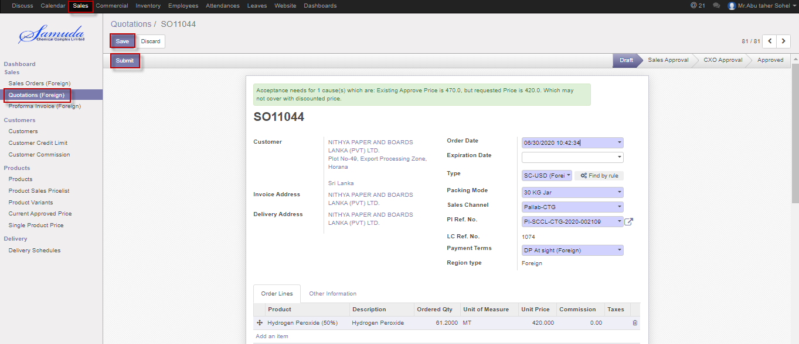

Figure: Create Quotation foreign

## 13.2 Quotation approval by head of sales

Head of sales will approve first approval. If unit price & commission no change then it will done state. Otherwise it will go accounts approval. Head of account will show notification top of the form his/her own window.

If unit price or commission changes then it will go for Management approval.

After apply the sales order head of sales will get the notification. He/she can update before approve.

To see the sales order request use the menu **Sales ‣ Pending SO**

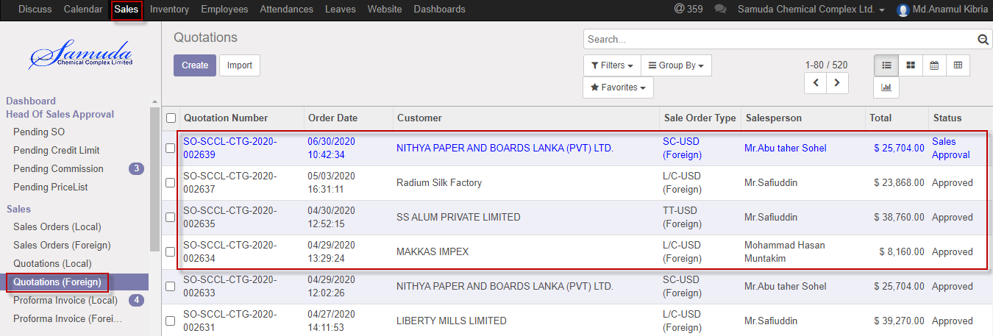

Figure: Quotation list view for Head of sales

Head of sales can confirm Quotation. Head of sales confirm the request by click on **Confirm** button & He/she can also capable to Reset to Draft. 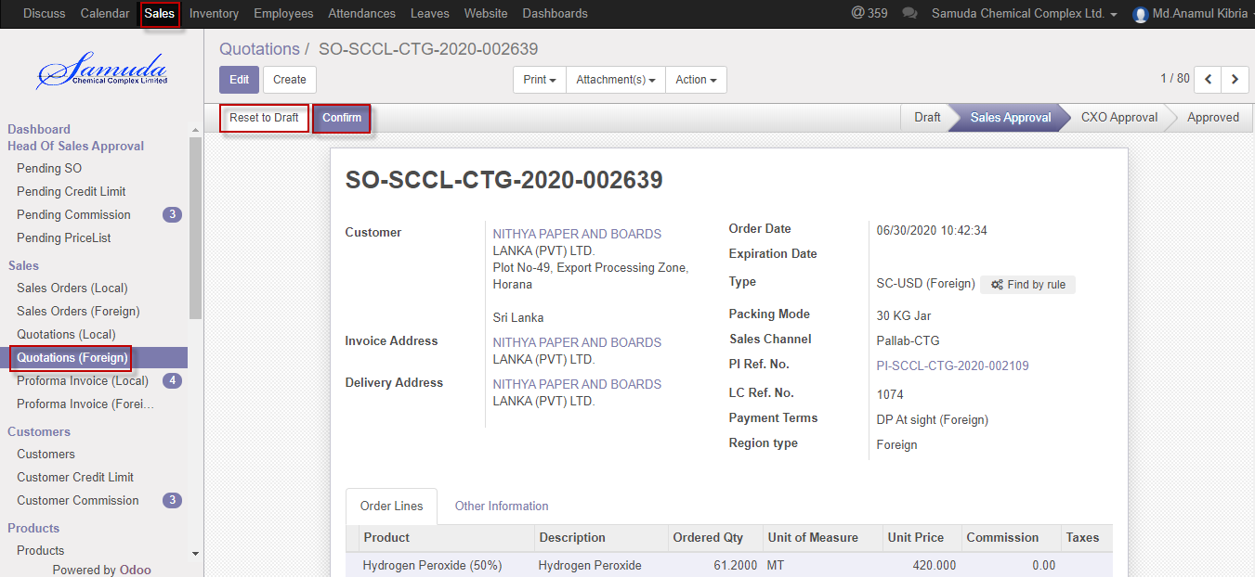

Figure: Quotation confirmed for Head of Sales

## 13.3 Quotation validate by head of accounts

After creation of SO, system will check the summation of Sales Order amount, Customer's Receivable amount, and total undelivered DO qty amount for that customer, total unposted invoiced amount for that customer with Customer's Credit Limit. If positive then there is no need of Second Approval for this case and Head of Sales can give final approval of Sales Order.

After confirmation the Quotation head of account will get the notification. He/she can capable to update before approve.

To see the Quotation request use the menu **Sales ‣ Pending SO**

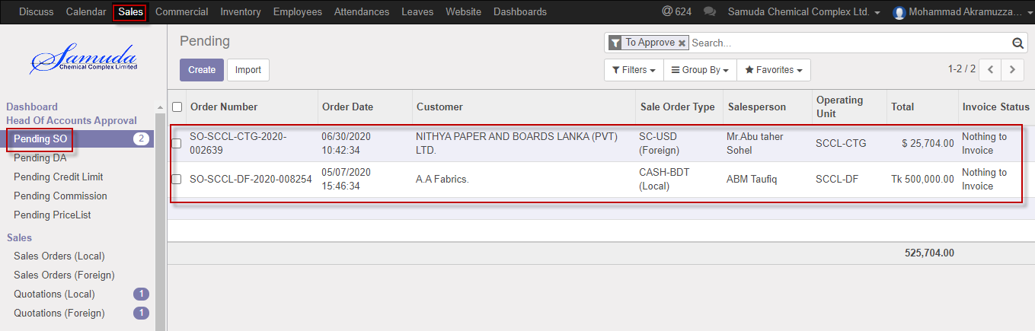

Figure: Quotation list view for Head of accounts

Head of account can validate Quotation. Head of account validate the request by click on **Validate** button 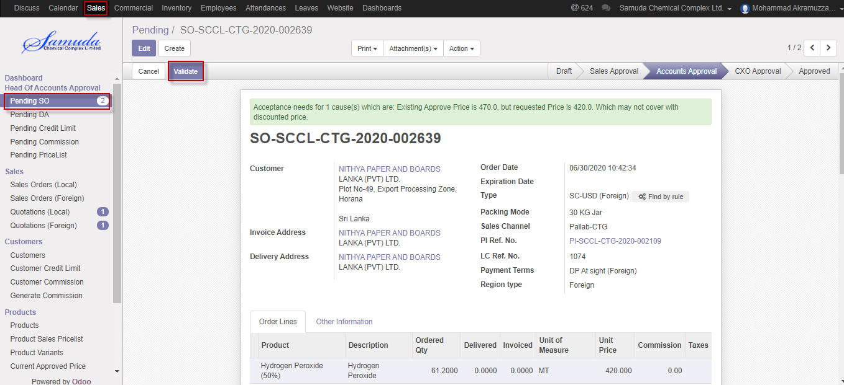

Figure: Quotation Validate

Head of account can able to Cancel Quotation. Head of account cancel the request by click on **Cancel** button 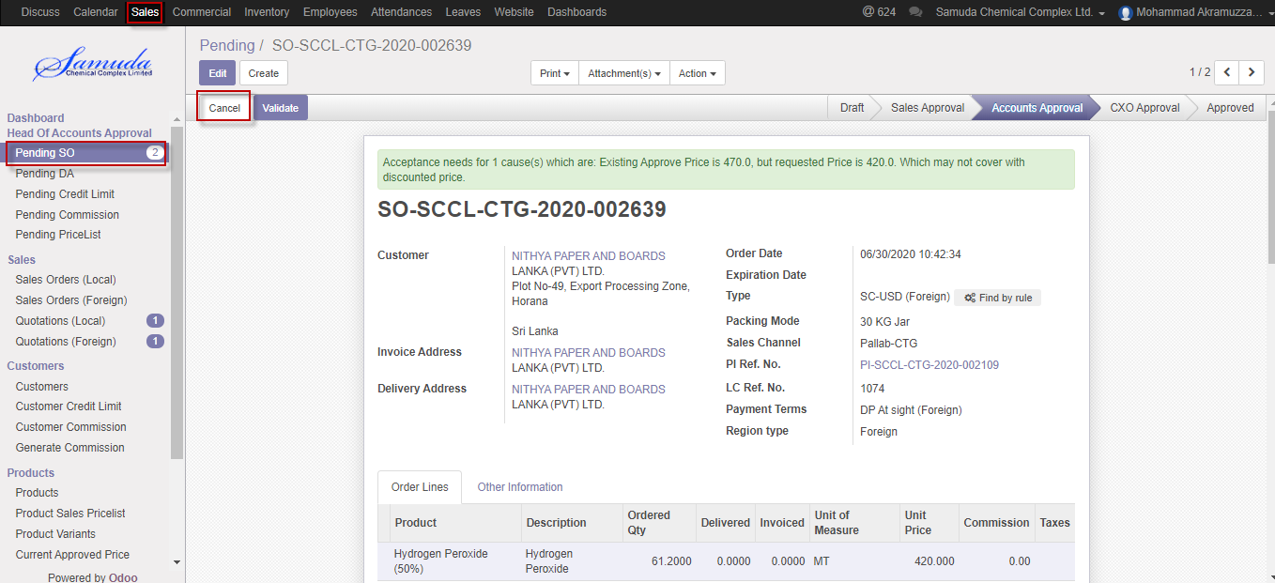

Figure: Quotation Cancel

## 13.4 Quotation approve by CXO

Quotation will go CXO/Director state if Quotation amount, Customer's Receivable amount, and total undelivered DO qty amount for that customer is bigger than credit limit.

After validate the Quotation CXO will get the notification. He/she can update or cancel before approve.

To see the sales order request use the menu **Sales ‣ Quotation (Foreign)**

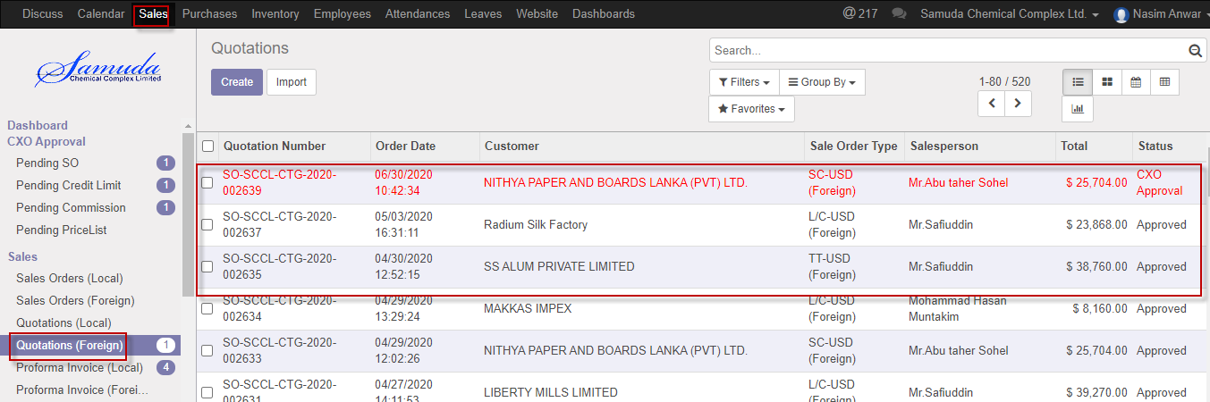

Figure: Quotation list view for CXO

CXO can approve Quotation. CXO approve the request by click on **Approve** button 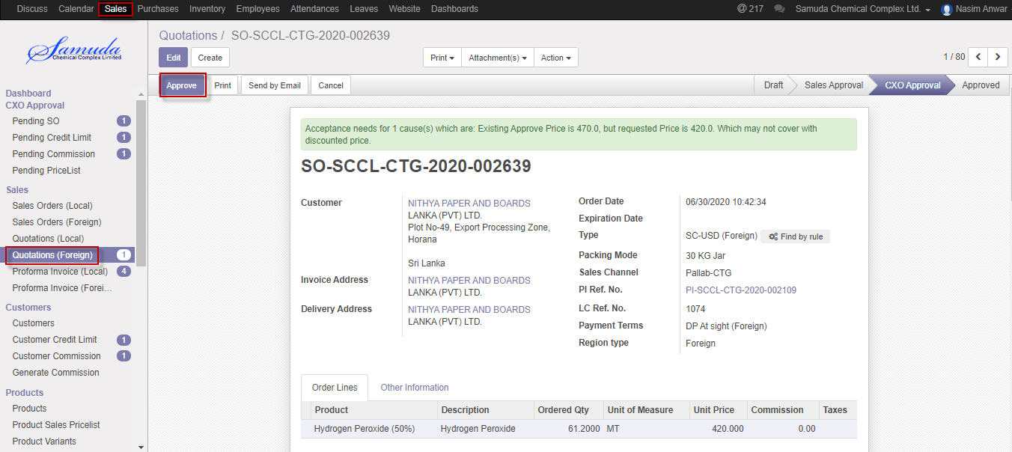

Figure: Quotation approve for CXO

Head of account & CXO is capable to cancel Quotation by click **Cancel** Button.

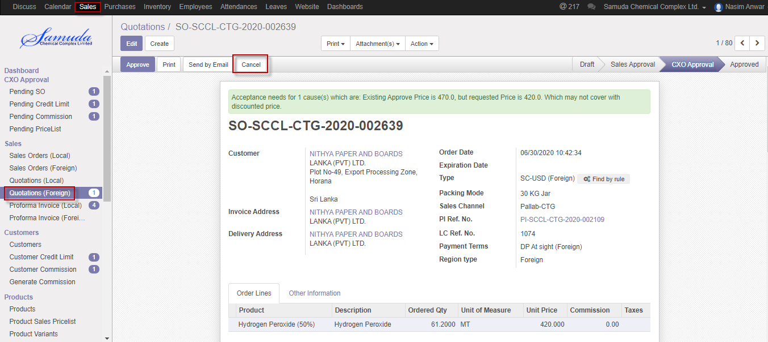

Figure: Quotation cancel

# 14. Sales Order (Foreign) View

Quotation will treat as a Sales order after all approval of Quotation. Approve sales order will go for Delivery authorization approval.

## 14.1 View Sales order by Foreign Sales User

Sales User will view the sales order using the menu **Sales ‣Sales> Sales Order (Foreign)** and click for View.

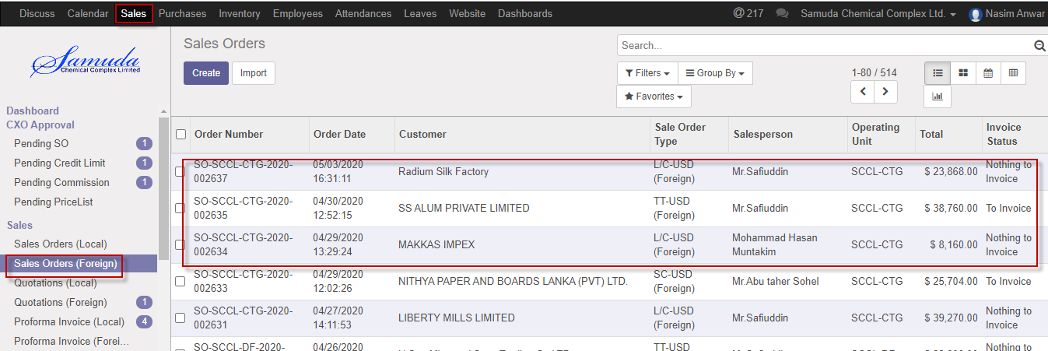

Figure: Sales Order Foreign List view

# 15. Delivery Authorization

Account Executive will confirm the delivery authorization. Delivery authorization will complete with in first step if Payment was done or 100MT business was ok. If payment was not done then will go for Head of accounts approval. Both DA local & Foreign approve by Accounts executive/Head of accounts.

## 15.1 Confirm DA by Account head/Account Executive

DA will be confirmed by Account head/Account executive.

We can view DA list view using the menu **Sales ‣ Delivery authorization**

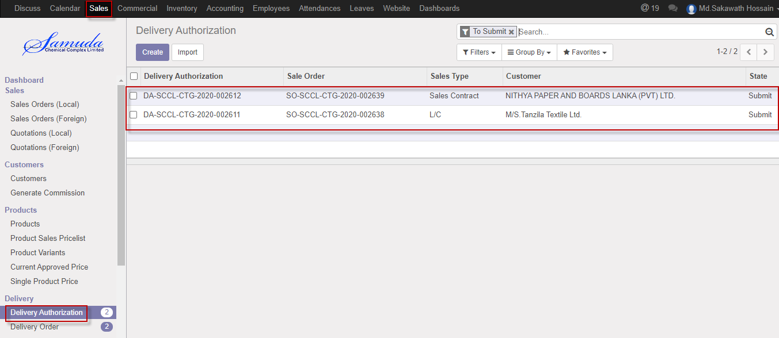

Figure: DA List view

We need to set the following:-

**All info**: All info will show auto after select the DA.

Accounts Executive/Head of accounts can confirm DA request by click on **Confirm** button

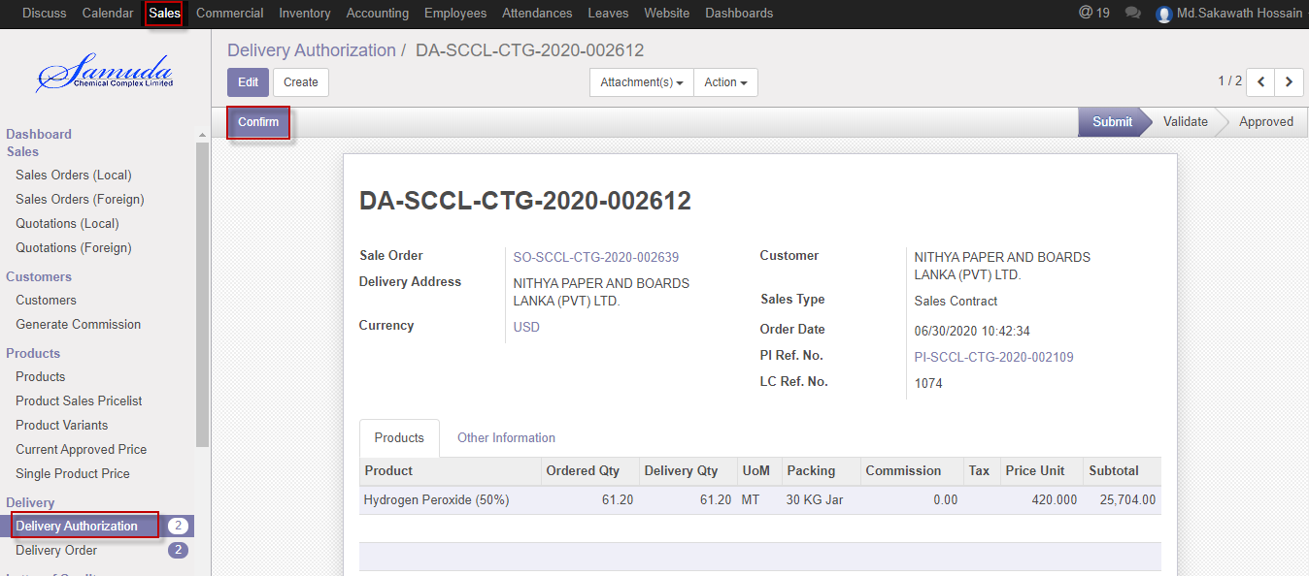

Figure: Confirm DA

## 15.2 DA Approval by Account head

Head of Sale Approval will confirm by Account head

We can create DA using the menu **Sales ‣ Delivery Authorization**

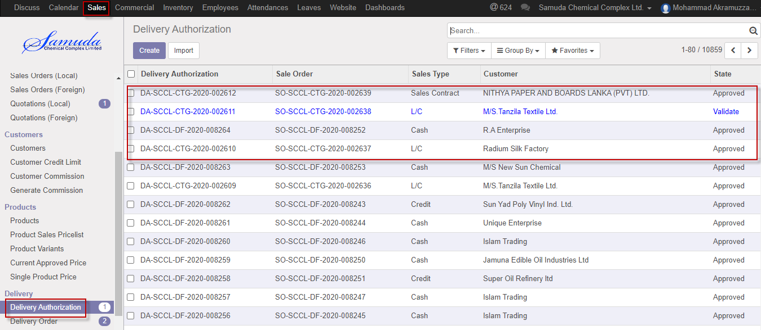

Figure: Head of accounts Approve List view

After confirm DA will ready for Approve .

After set all information click **Approve**.

Account head is capable to refuse click Refuse button

Account head is capable to reset to draft click Reset to draft button

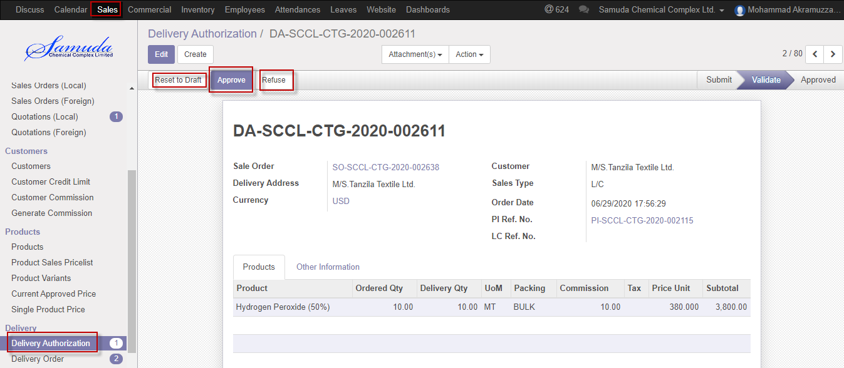

Figure: Approve ,Refuse & Reset to draft DA

# 16. Delivery Order

A delivery order before state of stock picking and after state of delivery authorization. Accounts executive or Accounts head will generate & confirm the delivery order. Delivery order will not go for Stock picking until DO confirmation. After Approved Delivery authorization Delivery order will create auto.

## 16.1 Delivery order view by accounts executive/accounts head

Delivery order will be viewed by account head.

We can view delivery order using the menu **sales ‣ Delivery** and click **Delivery order.**

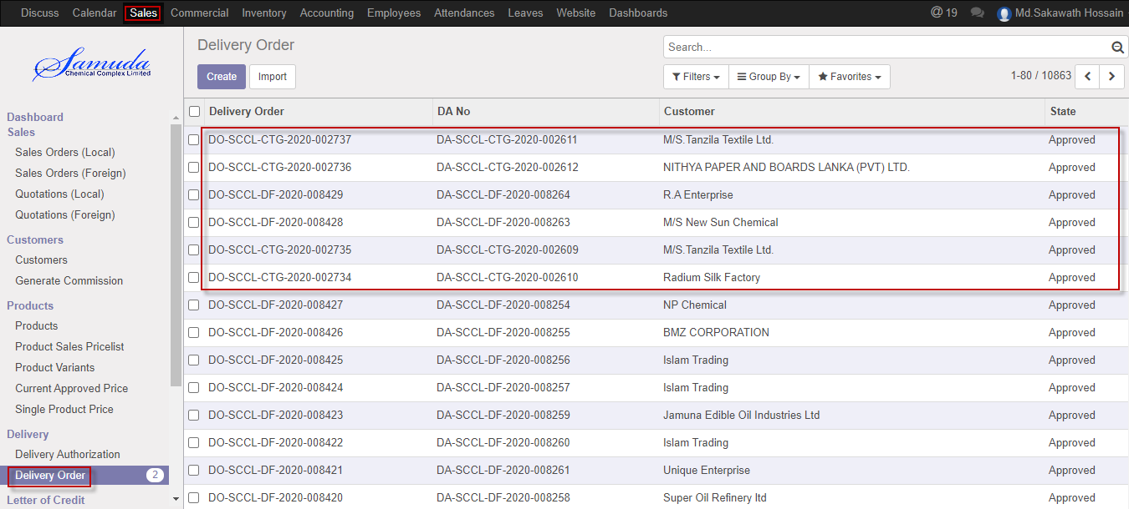

Figure: Delivery order List view

# 17. Delivery Chalan

Delivery chalan will generate auto after Approval of Delivery Authorization & Delivery Man will validate the Delivery chalan using the Delivery page. Create Back order Pop up will appear if chalan can partial validate.

## 17.1 Delivery chalan validate by Delivery man

Delivery Chalan will be Validate/Edit by Delivery man.

We can create Delivery Challan using the menu **inventory** and click **To do** button

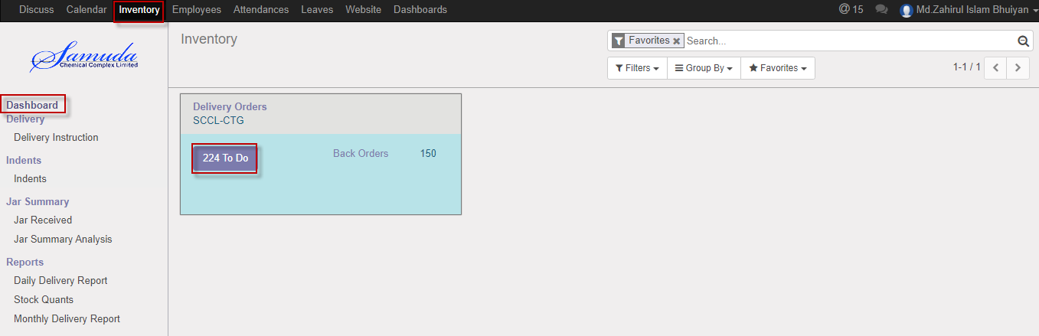

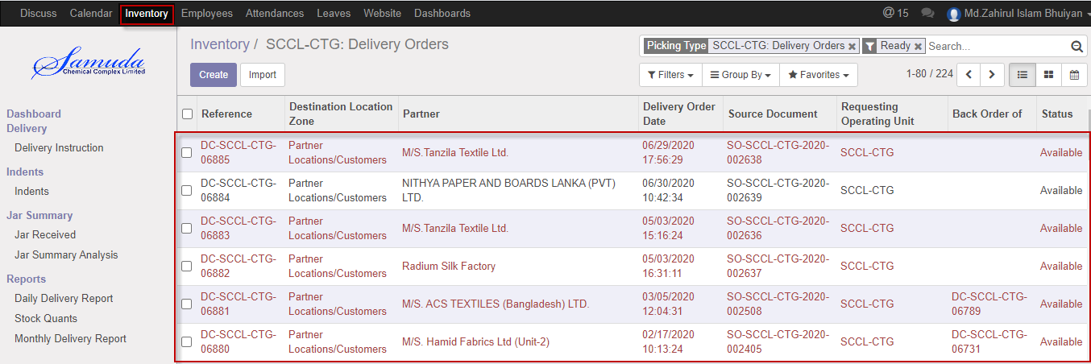

Figure: Delivery Chalan List view

We need to set the following:-

Delivery chalan all information will come auto after select a chalan no

We can Validate Delivery Challan using the menu **inventory>Dashboard>DC** and click **Validate** button

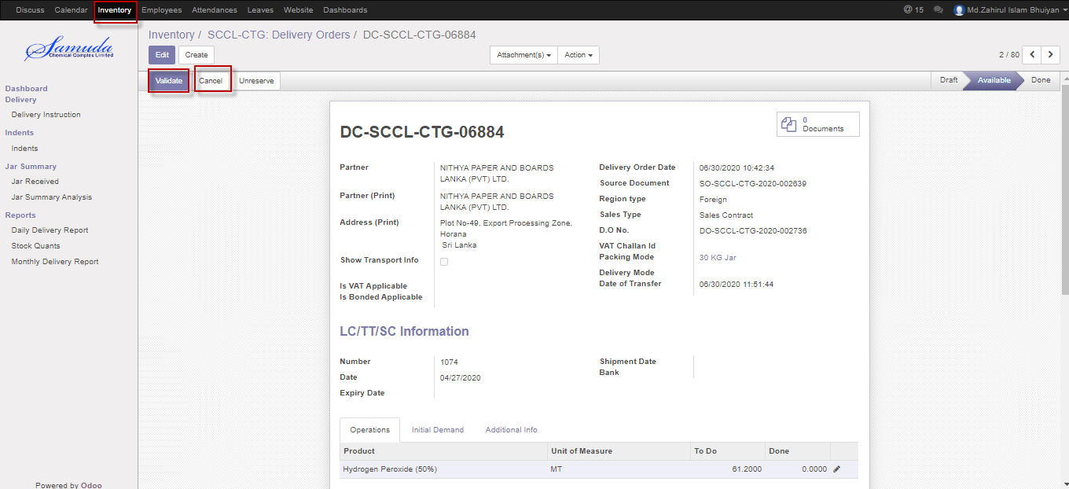

Figure: validate a delivery chalan

# 18. Delivery Schedules

Delivery schedule will create by Sales executive .After Completed Delivery Schedule Mail will go through to Delivery man with Attachment. Then Delivery man will create Delivery chalan.

## 18.1 Create Delivery Schedule by Sales executive

Delivery schedule will be created/Edit by Sales executive

We can create sales order using the menu **Sales ‣ Delivery>>Delivery Schedule** and click **Create.**

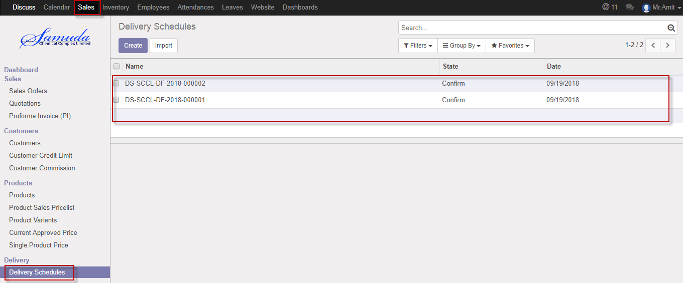

Figure: Delivery Schedule List view

We need to set the following:-

**Operating unit**: Select operating unit.

**Customer:** Select Customer.

**Pending DO:** Select pending DO.

**Order Qty:** Order Qty will come auto.

**Schedule Qty:** Enter Schedule qty.

After entering all information click **Save & Confirm**.

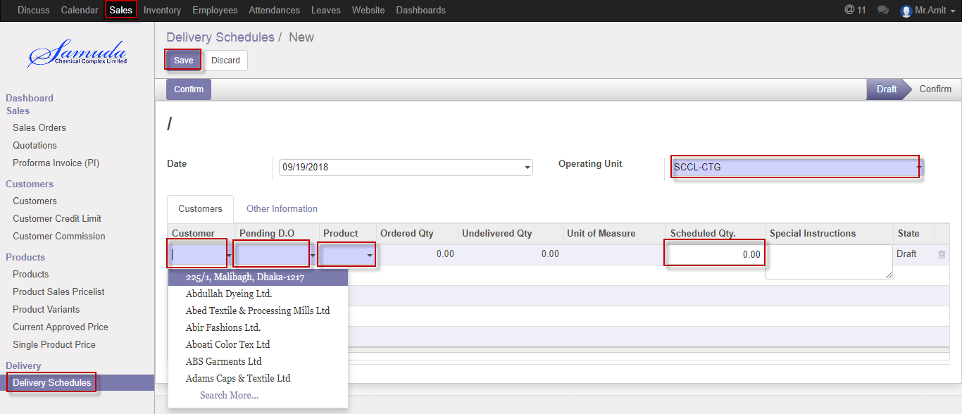

Figure: Create delivery Schedule

# 19. Delivery Instruction

Delivery Man will view delivery instruction. Then He will create Delivery challan then will click done checked.

## 19.1 Delivery instruction view by Delivery operation

Delivery order will be viewed by Delivery operation

We can view delivery Instruction using the menu **Inventory ‣ Delivery>>Delivery instruction**

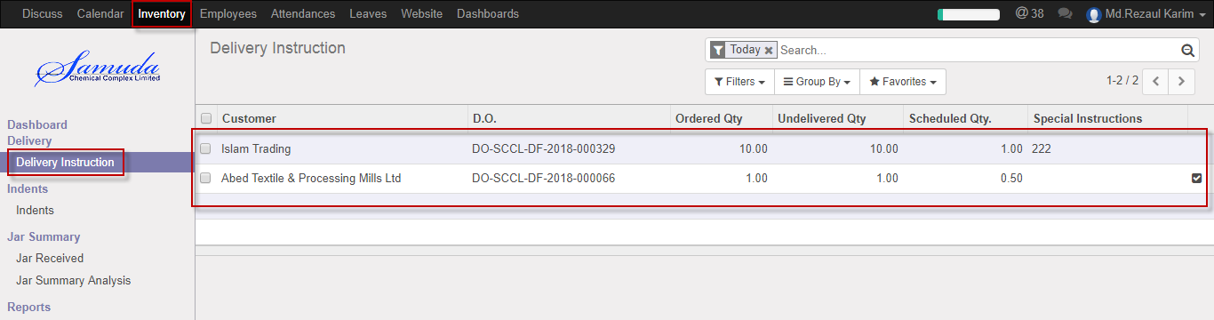

Figure: Delivery instruction List view

Delivery Man will done the instruction click Unchecked button

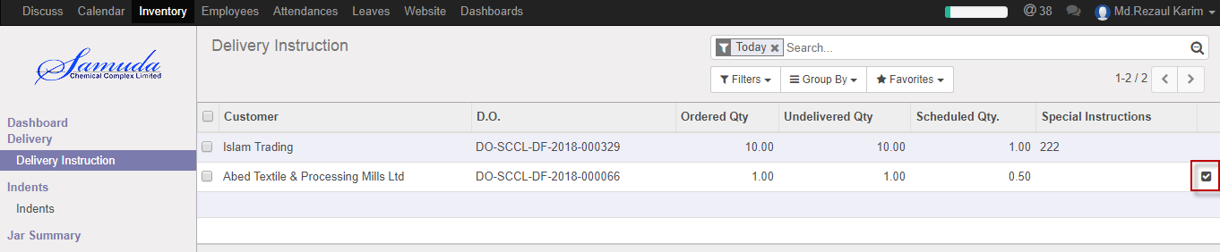

# 20. Customer Invoice

Customer Invoice will ready and will come under customer invoice menu after confirm Delivery chalan.

Then Account executive will validate customer invoice.

## 20.1 Customer Invoice Validate by Accounts executive

To see the Customer Invoice request use the menu **accounting ‣ Customer Invoice**

Accounts Executive can Validate Customer Invoice. Accounts Executive Validate the request by click on **Validate** button

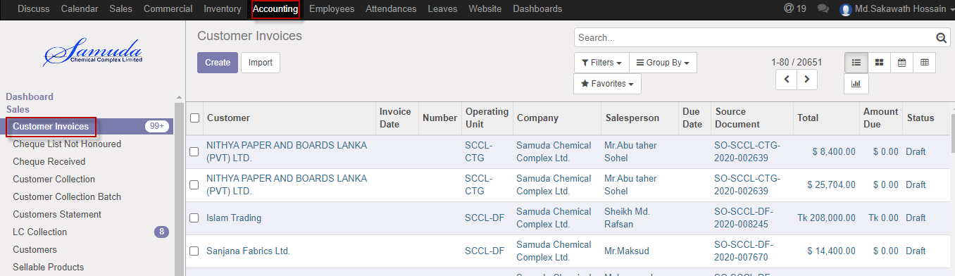

Figure: Customer invoice list view

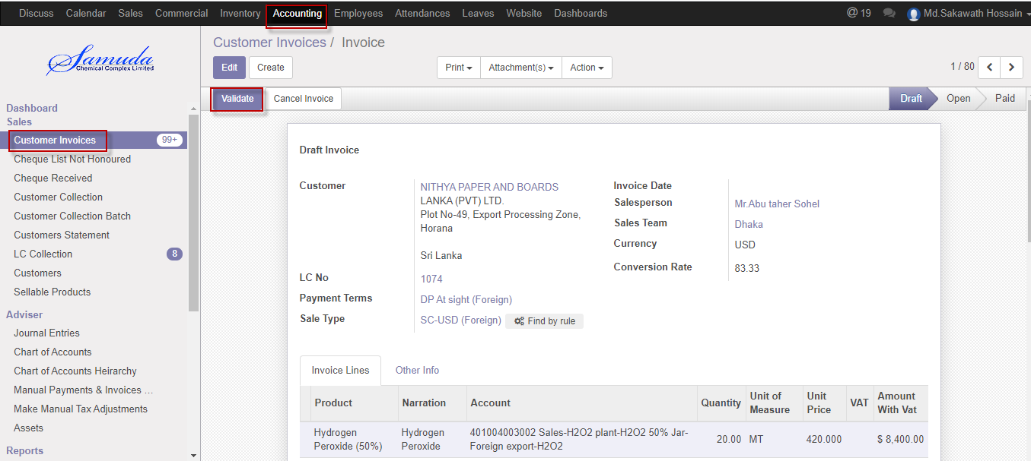

Figure: Customer Invoice Validate

Accounts Executive is capable to cancel Customer Invoice by click **Cancel** Button.

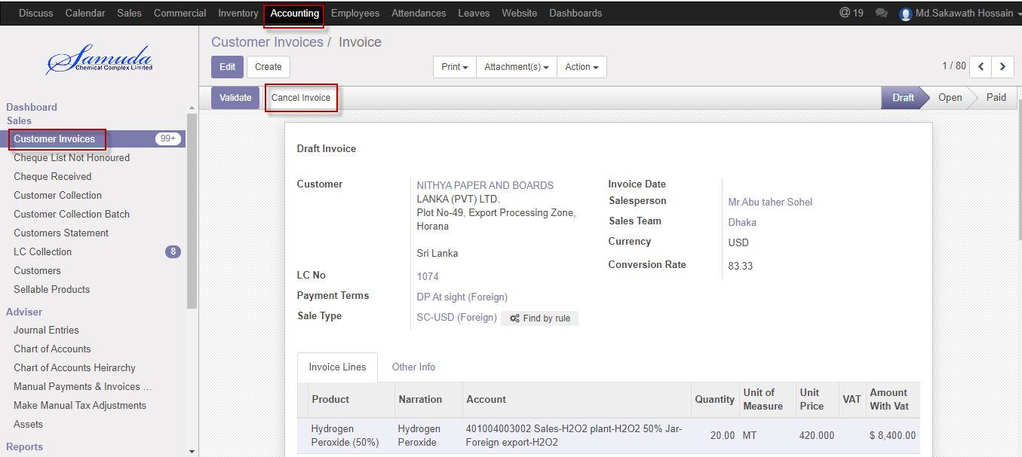

Figure: Customer Invoice cancels

# 21. Cheque Received

Cheque received made by Accounts executive or Head of accounts. Those SO against cheque will receive which SO type is cash.

## 21.1 Cheque Received by Accounts executive

Cheque received will be created/Edit by Accounts executive

We can create Cheque received using the menu **Accounting>>sales>>Cheque Received ‣**and click **Create.**

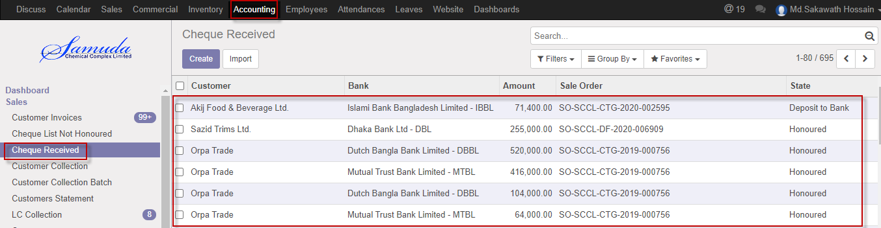Figure: Cheque received List view

We need to set the following:-

**Customer**: Select customer.

**Collection Journal:** Select a collection journal.

**Customer Bank:** Select a customer Bank.

**Branch Name:** Select branch name

**Cheque no:** Enter a cheque no

**Currency:** Select currency.

**Date on Cheque:** Select date.

**Amount:** Enter payment amount.

**Sales order:** Select sales order if require.

**Narration:** Enter Narration.

After entering all information click **Save & Received**.

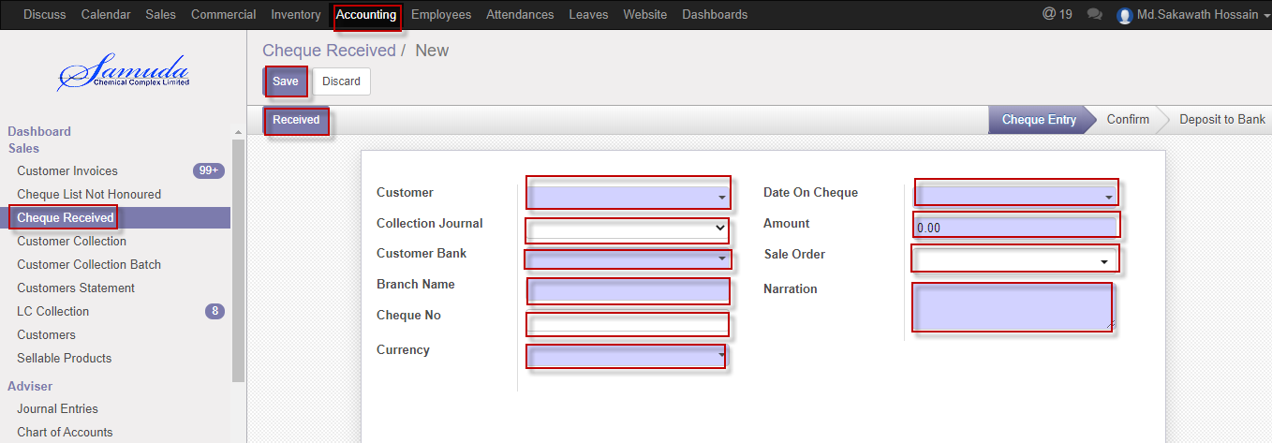

Figure: Create Cheque Received

# 22. Customer Collection

Customer collection made by Accounts executive or Head of accounts.

## 22.1 Create Customer collection by Accounts executive

Customer collection will be created/Edit by Accounts executive

We can create Customer collection using the menu **Accounting>>sales>>Customer collection‣** and click **Create.**

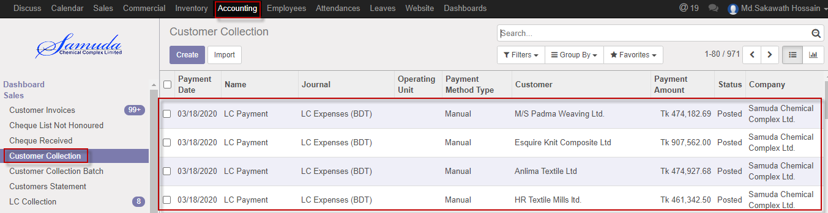

Figure: Customer Collection List view

We need to set the following:-

**Customer**: Select customer.

**Collection Journal:** Select a collection journal.

**Customer Bank:** Select a customer Bank.

**Branch Name:** Select branch name

**Currency:** Select currency.

**Amount:** Enter payment amount.

**Auto Invoice paid:** invoice will paid auto SO sequence order wise after select auto invoice paid.

**Sales order:** Select sales order if require.

**Narration:** Enter Narration.

.

After entering all information click **Save & Confirm**.

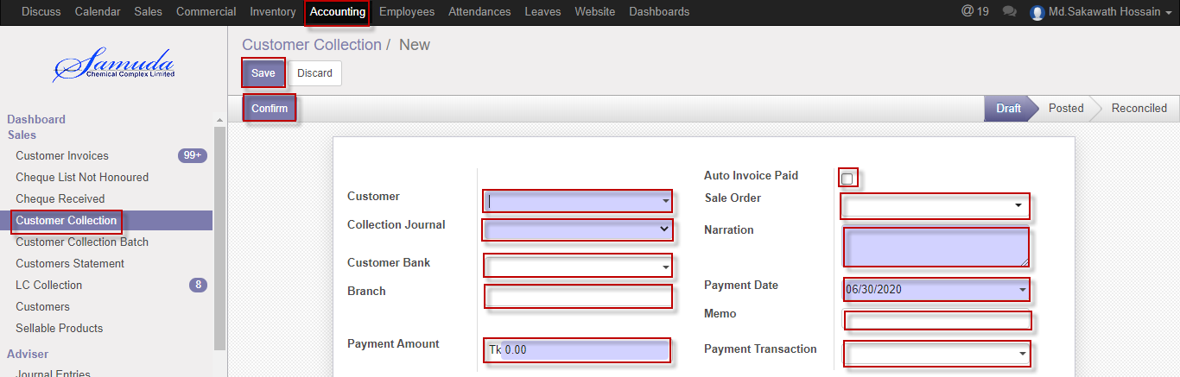

Figure: Create Customer collection

# 23. Customer Collection Batch

Customer collection batch made by Accounts executive or Head of accounts.

A set of group customer collection will collect from using this page.

## 23.1 Create Customer collection batch by Accounts executive

Customer collection batch will be created/Edit by Accounts executive

We can create Customer collection batch using the menu **Accounting>>Sales>>Customer collection batch‣** and click **Create.**

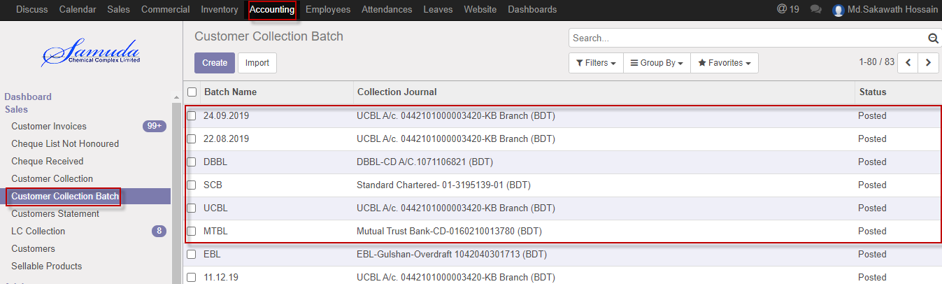

Figure: Customer Collection batch List view

We need to set the following:-

**Batch Name**: Enter a Batch name.

**Collection Journal:** Select a collection journal.

**Customer:** Select multiple customers to collect customer payment at a time.

**Branch Name:** Select branch name

**Currency:** Select currency.

**Amount:** Enter payment amount.

**Auto Invoice paid:** invoice will paid auto SO sequence order wise after select auto invoice paid.

**Sales order:** Select sales order if require.

**Narration:** Enter Narration.

After entering all information click **Save & Confirm**.

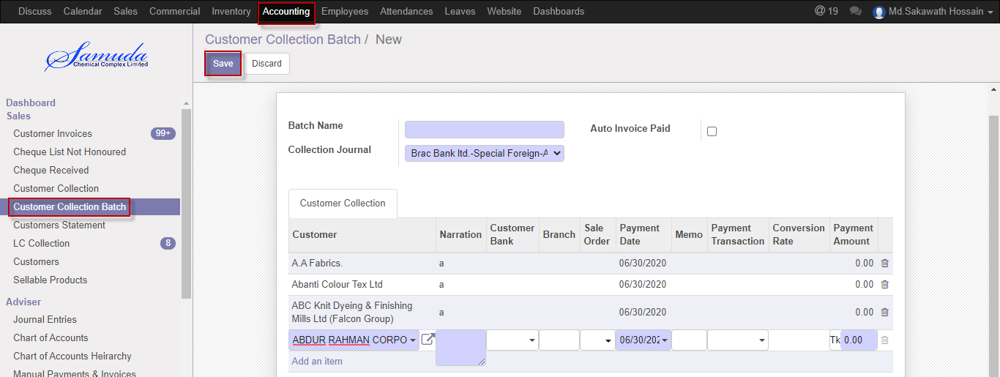

Figure: Create Customer collection Batch

# 24. LC Collection

Local & foreign LC related customer collection will collect using this form.

Accounts executive/Head of accounts will make this transaction.

## 24.1 Create LC collection by Accounts executive

LC collection batch will be created/Edit by Accounts executive

We can create LC collection using the menu **Accounting>>Sales>>LC collection‣** and click **Create.**

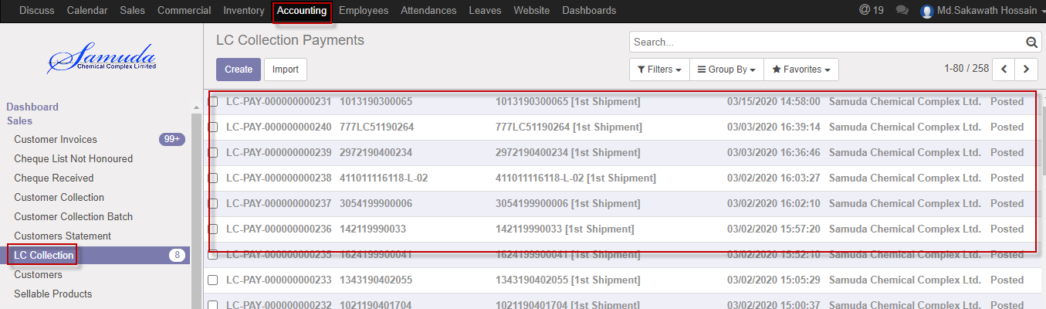

Figure: LC Collection List view

We need to set the following:-

**Date**: Current date will come auto.

**Account Journal:** Select an account journal.

**LC:** Select a LC no.

**Shipment:** Select Shipment.

**Invoice:** Select invoice.

**Profit Centre:** Profit center will come auto after select LC.

**Invoice amount:** invoice will come auto after select invoice.

**Currency:** Currency will come auto after select invoice.

**Currency rate:** Currency rate will come auto after select invoice.

**Base Amount:** Base amount will come auto after select invoice.

**Narration:** Enter Narration.

After entering all information click **Save & Confirm**.

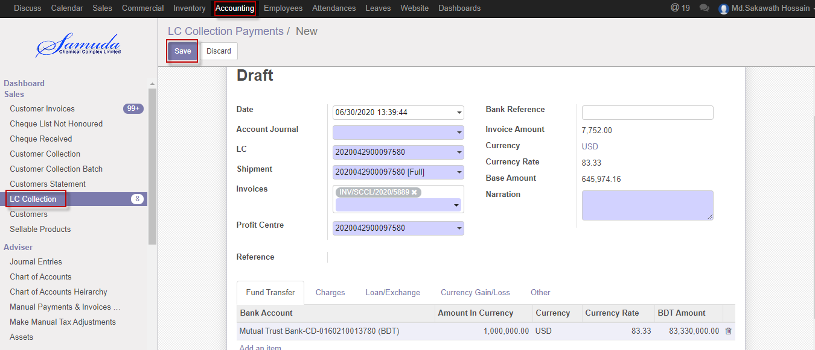

Figure: Create LC Collection

# 25. Reports

In sales module reports contain all the sales related information. Reports document containing information graphic, or tabular form, prepared on ad hoc, periodic, recurring, regular, or as required basis.

## 25.1 Proforma Invoice reports (Local & Foreign) view by Sales executive

To see the Proforma invoice reports use the menu **Sales ‣Select>Proforma Invoice>** **Print>Proforma Invoice**

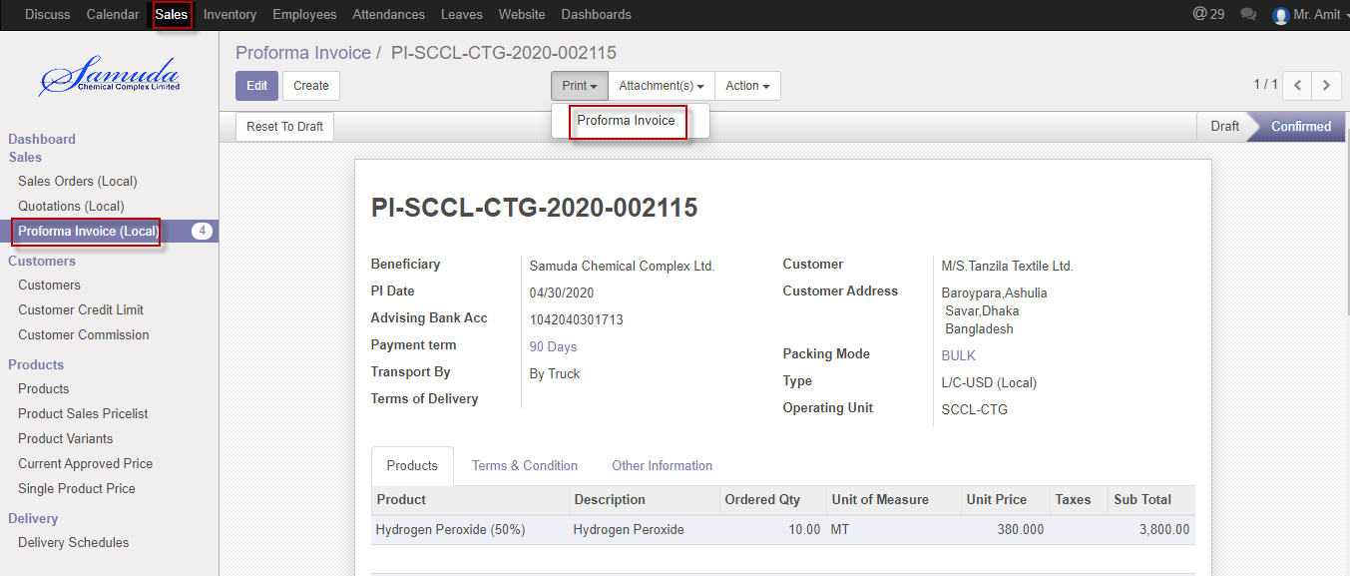

Figure: Proforma invoice reports Form view

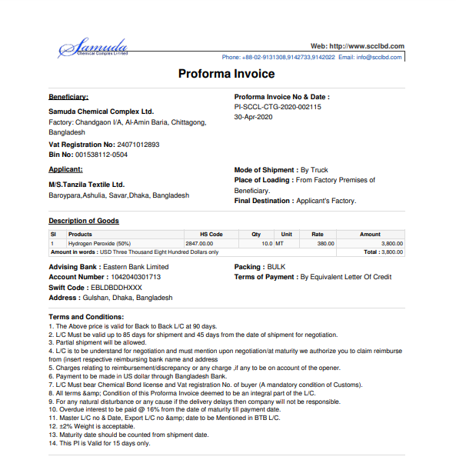Figure: Proforma invoice Local reports PDF format

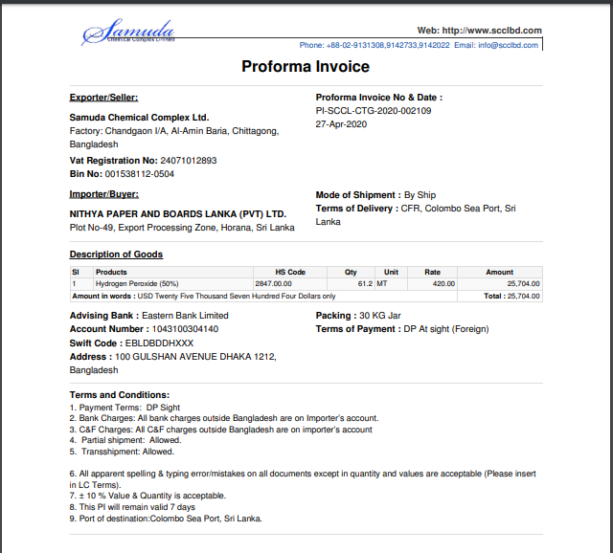

Figure: Proforma invoice Foreign reports PDF format

## 25.2 Sales Order reports (Local & Foreign) view by Sales executive

To see the sales order reports use the menu **Sales ‣Select sales order from list>** **Print>Sales order**

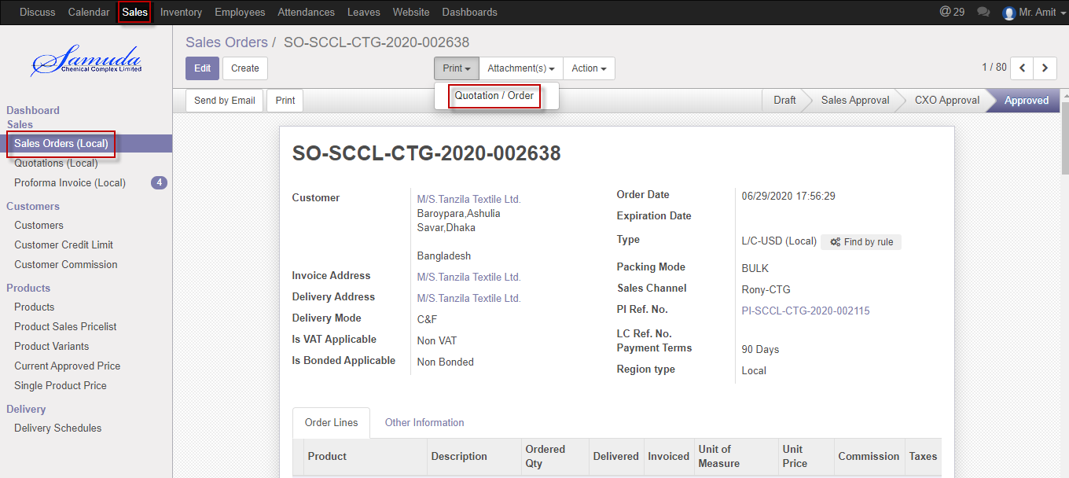

Figure: Sales order (Local) reports Form view

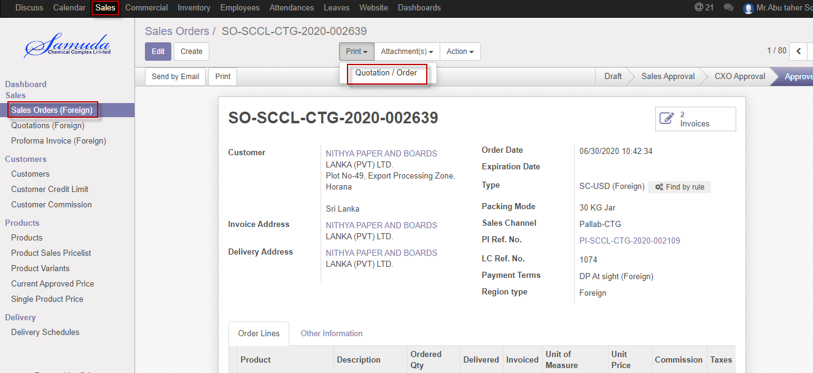

Figure: Sales order (LForeign) reports Form view

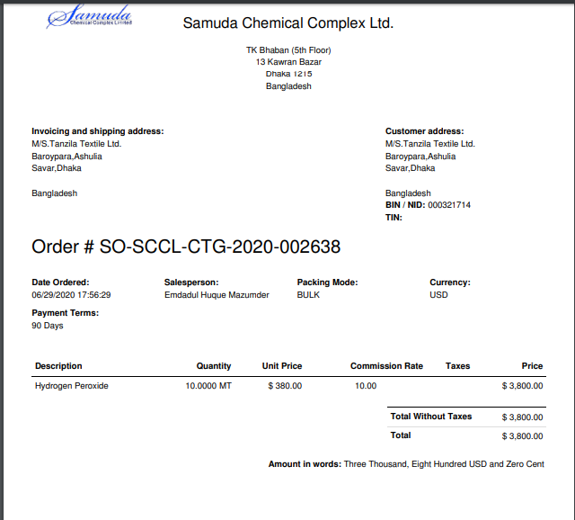

Figure: Sales order (Local) report PDF format

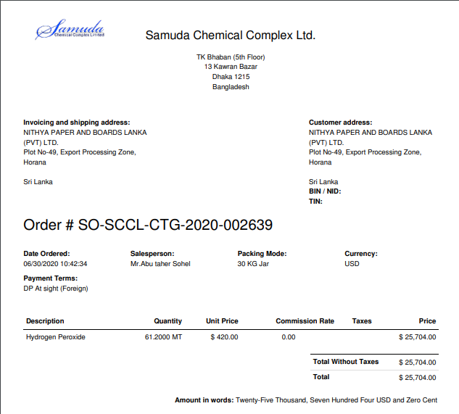

Figure: Sales order (Foreign) report PDF format

## 25.3 Customer credit limit reports view by Admin

To see the customer credit limits reports use the menu **Sales ‣select customer credit limit from list>** **Print>Credit limit summary**

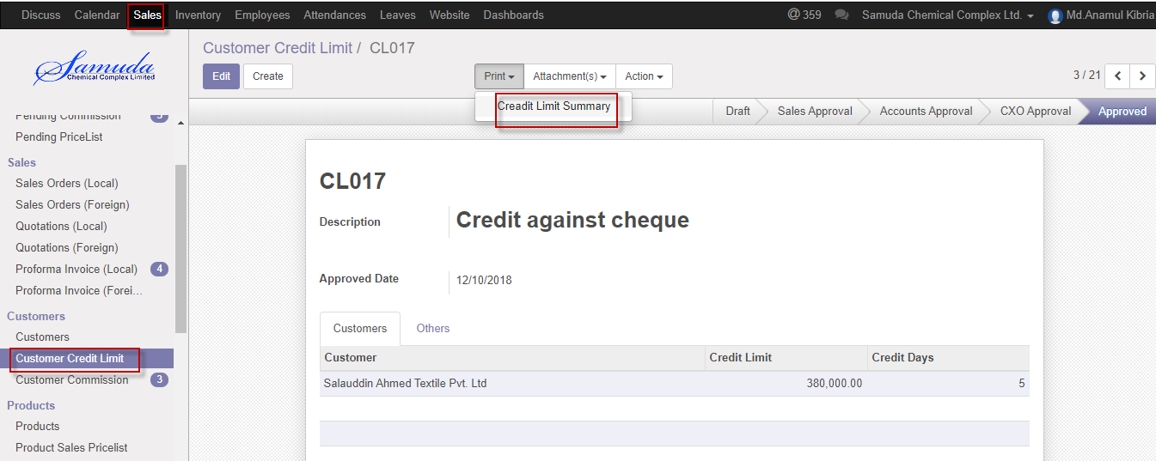

Figure: Customer credit limit reports print view

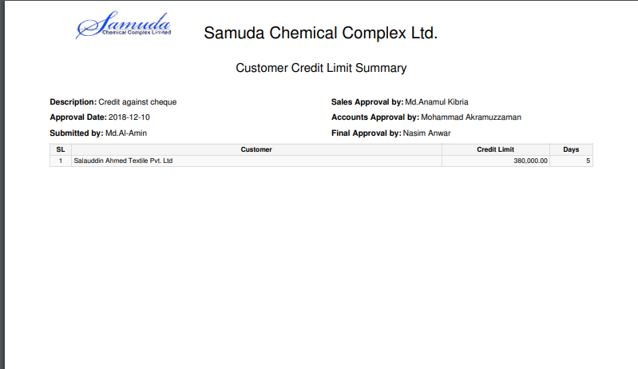Figure: Customer credit limit reports PDF format

## 25.4 Customer commission reports view by Admin

To see the customer commission reports use the menu **Sales ‣select customer commission from list>** **Print>Commission report**

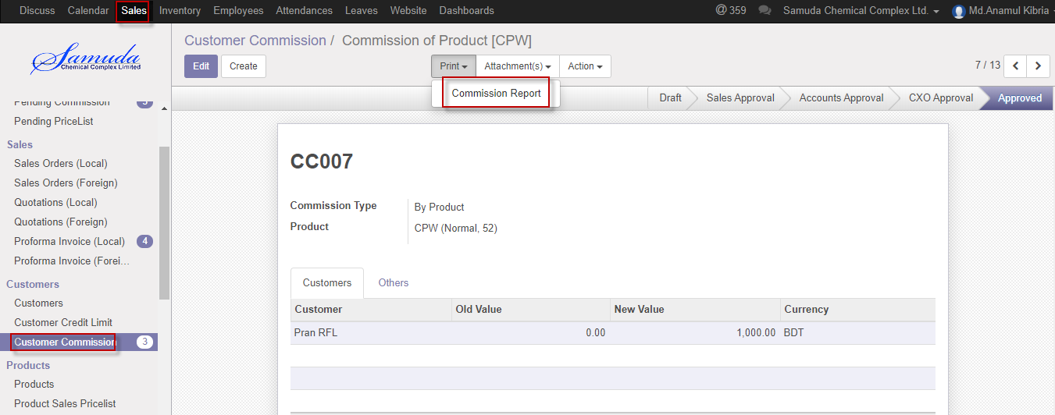

Figure: Customer commission reports print view

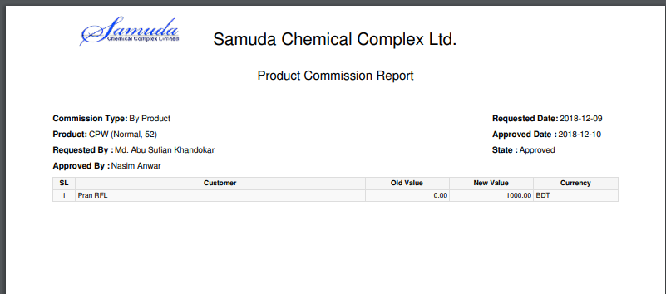

Figure: Customer commission reports PDF format

## 25.5 Product sales pricelist reports view by Sales executive

To see the product sales pricelist reports use the menu **Sales ‣select product sales pricelist from list>** **Print>Product pricelist**

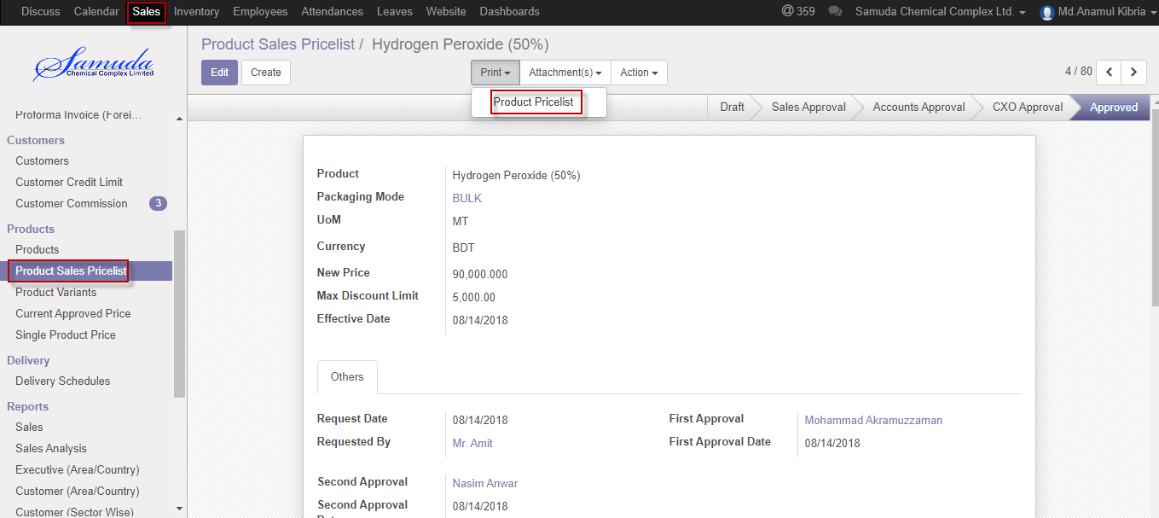

Figure: Product sales pricelist reports print view

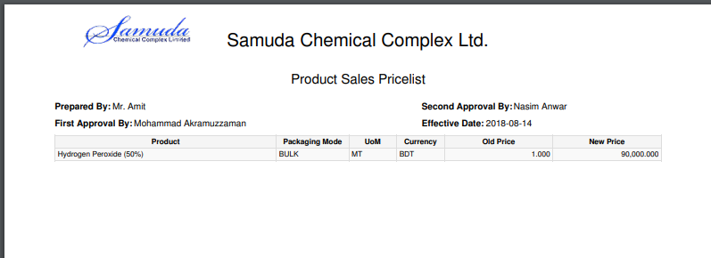

Figure: Product sales pricelist PDF format

## 25.6 Delivery Order reports view by account head

To see the Delivery Order reports use the menu **Sales ‣select Delivery Order from list>** **Print>Delivery Order**

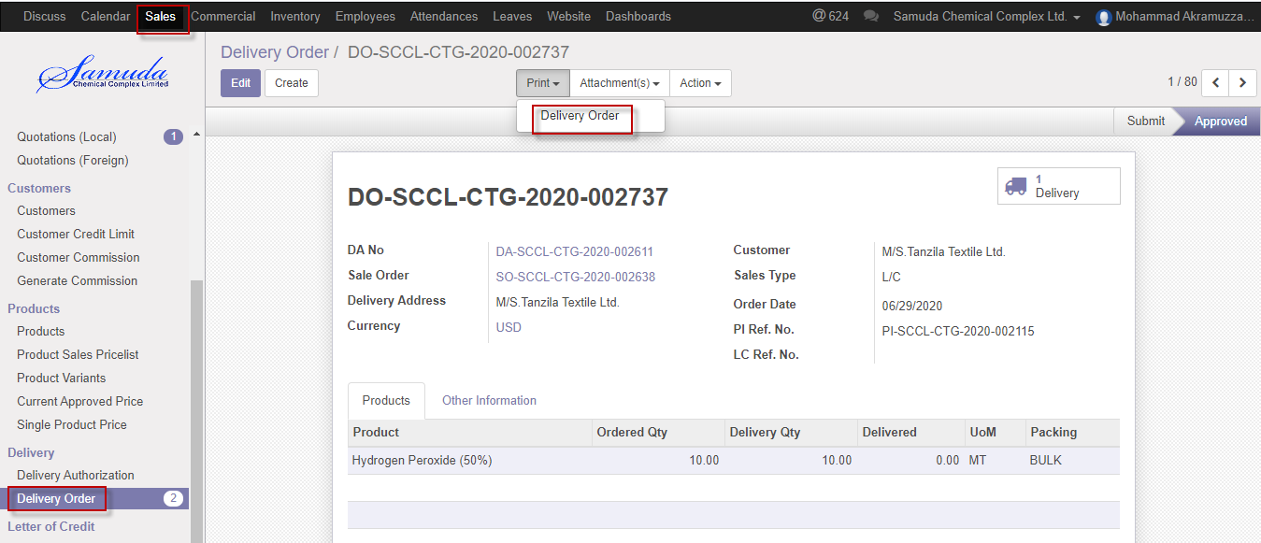

Figure: Delivery Order reports print view

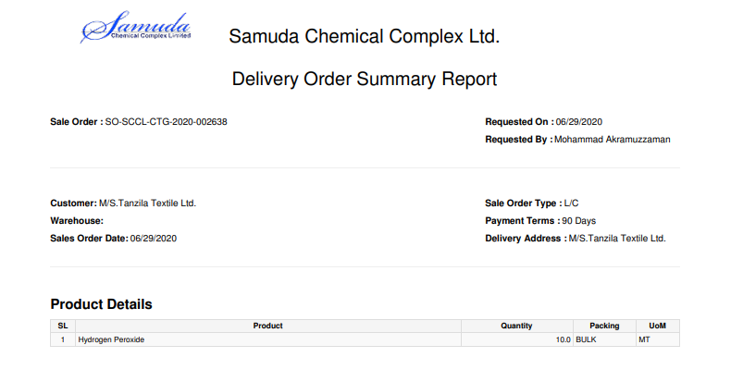

Figure: Delivery Order reports PDF format

## 25.7 Sales Analysis reports view by CXO

To see the Sales reports use the menu **Sales ‣Reports>Sales** Analysis>>Click to expand and Select an option to View reports

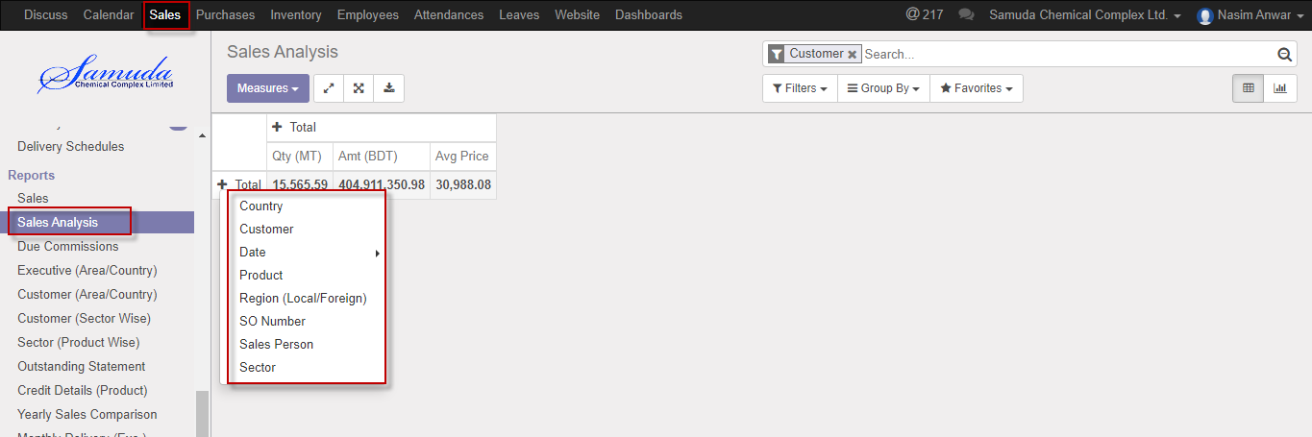

Figure: Sales print view

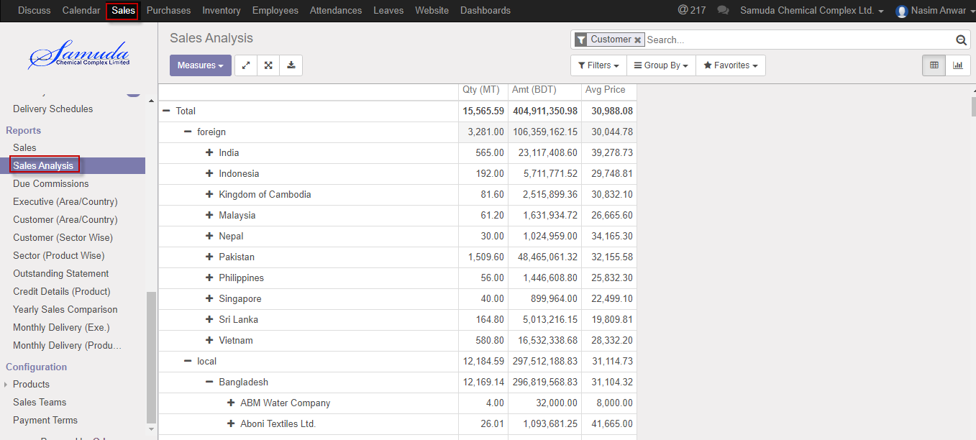

Figure: Sales Analysis expand view

## 25.8 Executive Sales Reports (Area/Country wise) view by Admin

To see the daily reports use the menu **Sales ‣Reports>** **Executive Sales reports (Area/Country wise)**

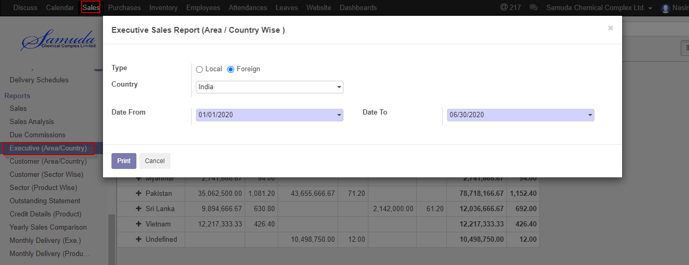

Figure: Executive sales report (Area/Country wise)

We need to set the following:-

**Type**: Select a type Local & Foreign.

**Country**: Select country.

**Date**: Select date range.

After entering all information click **Print**.

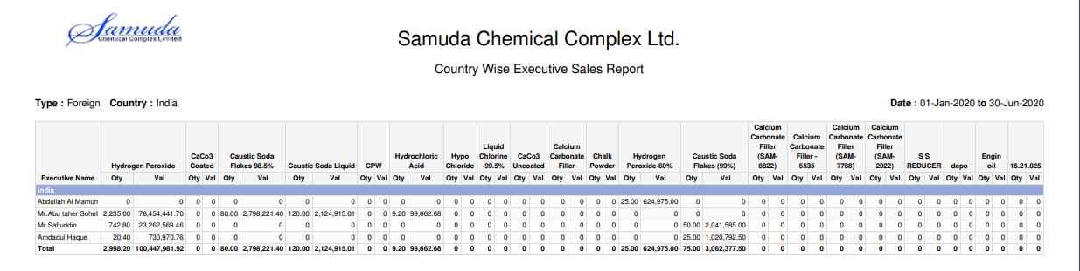

Figure: Executive sales report (Area/Country wise) PDF format

## 25.9 Customer Sales Reports (Area/Country wise) view by Admin

To see the daily reports use the menu **Sales ‣Reports>** **Customer Sales reports (Area/Country wise)**

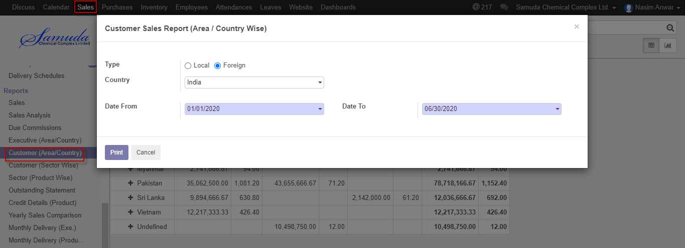

Figure: Customer sales report (Area/Country wise)

We need to set the following:-

**Type**: Select a type Local & Foreign.

**Country**: Select country.

**Date**: Select date range.

After entering all information click **Print**.

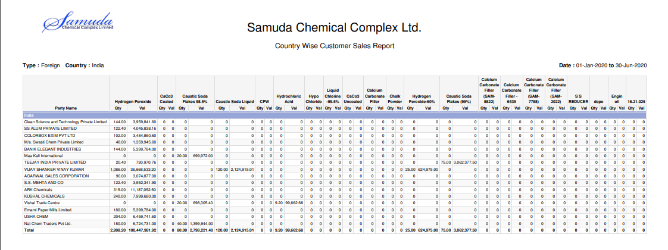

Figure: Customer sales report (Area/Country wise) PDF format

## 25.10 Customer Sector wise sales reports view by Admin

To see the Customer sector wise sales reports use the menu **Sales ‣Reports>Customer (Sector wise)**

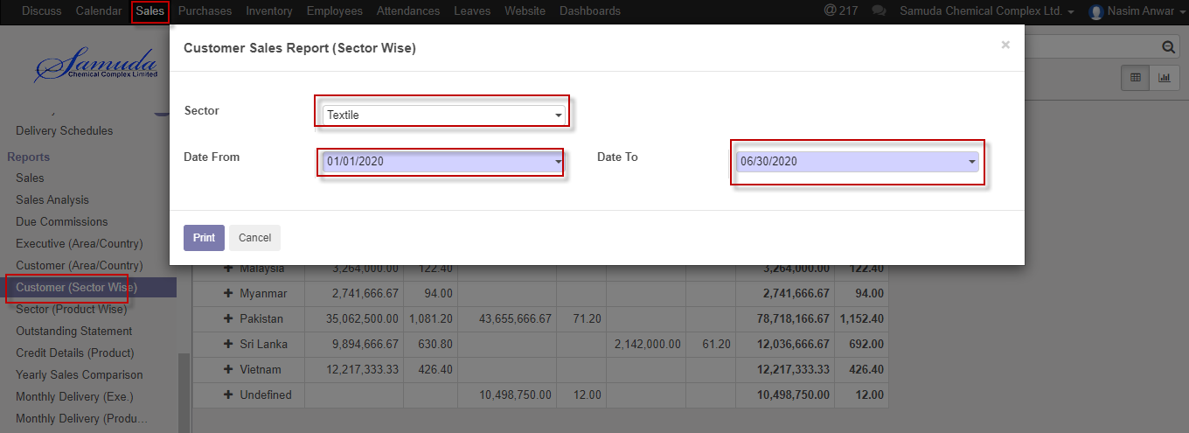

Figure: Customer (Sector wise) reports print view

We need to set the following:-

**Sector**: Select sector.

**Date**: Select date range.

After entering all information click **Print**.

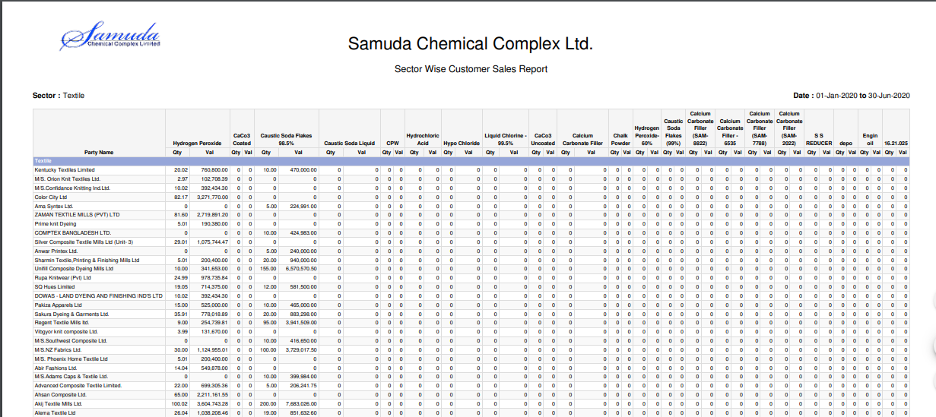

Figure: Customer (Sector wise) reports PDF format

## 25.11 Sector product wise sales reports view by Admin

To see sector product wise sales reports use the menu **Sales ‣Reports>Sector (Product wise)**

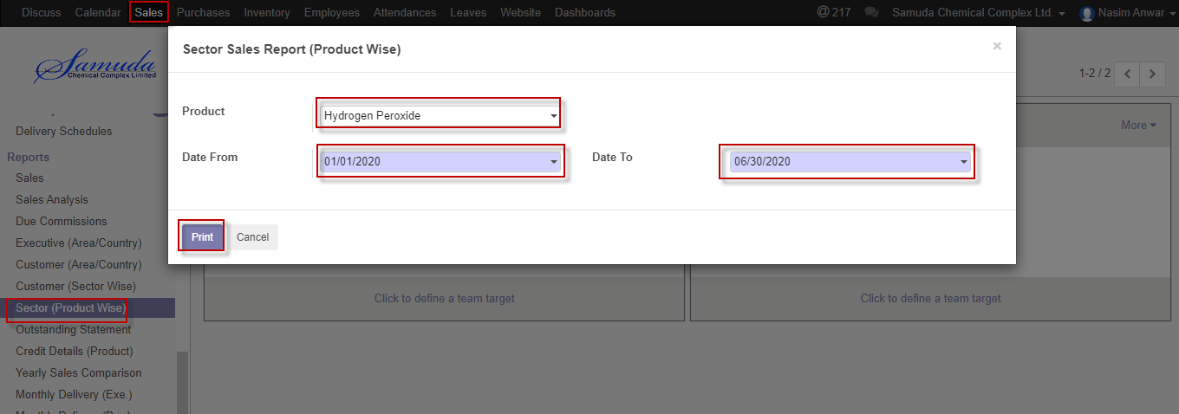

Figure: Sector (Product wise) reports print view

We need to set the following:-

**Product**: Select product.

**Date**: Select date range.

After entering all information click **Print**.

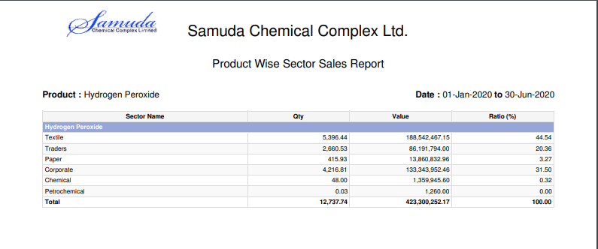

Figure: Sector (Product wise) reports PDF format

## 25.12 Outstanding Statement reports view by Admin

To see the Outstanding statement reports use the menu **Sales ‣Reports>Outstanding statement**

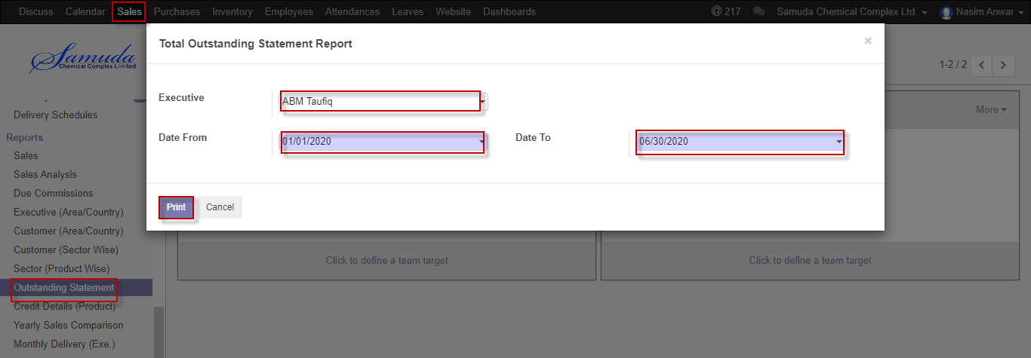

Figure: Outstanding statement print view

We need to set the following:-

**Executive**: Select executive.

**Date**: Select date range.

After entering all information click **Print**.

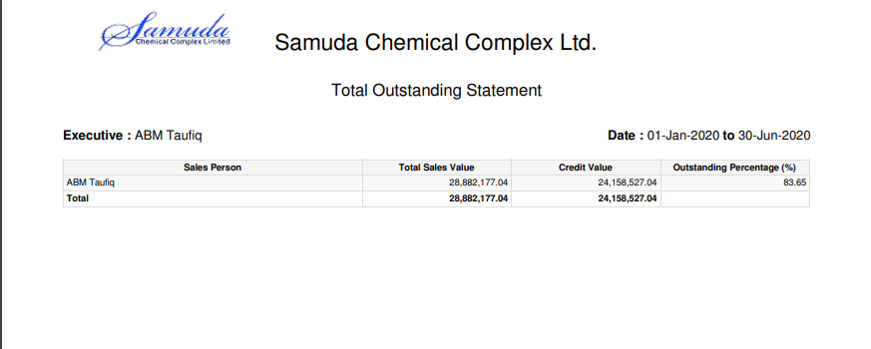

Figure: Outstanding statement reports PDF format

## 25.13 Credit Details (Product) reports view by Admin

To see the Credit Details (Product) reports use the menu **Sales ‣Reports>Credit Details (Product)**

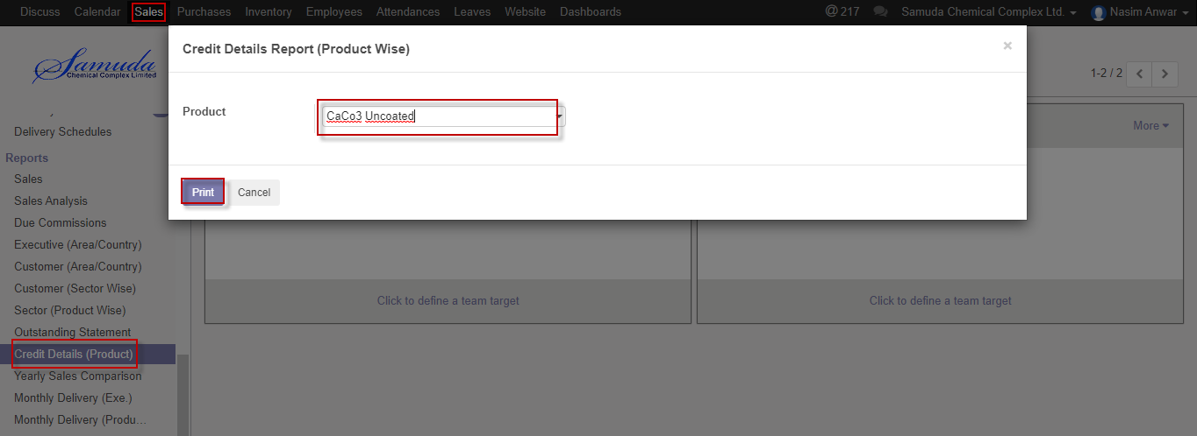

Figure: Credit Details (Product) reports print view

We need to set the following:-

**Product**: Select product.

After entering all information click **Print**.

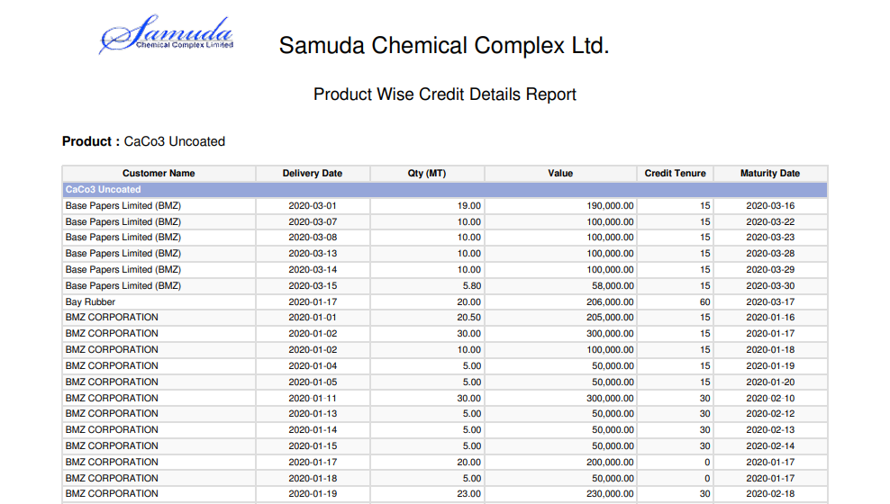

Figure: Credit Details (Product) reports PDF format

## 25.14 Yearly Sales Comparison reports view by Admin

To see Yearly Sales Comparison reports use the menu **Sales ‣Reports>Yearly Sales Comparison**

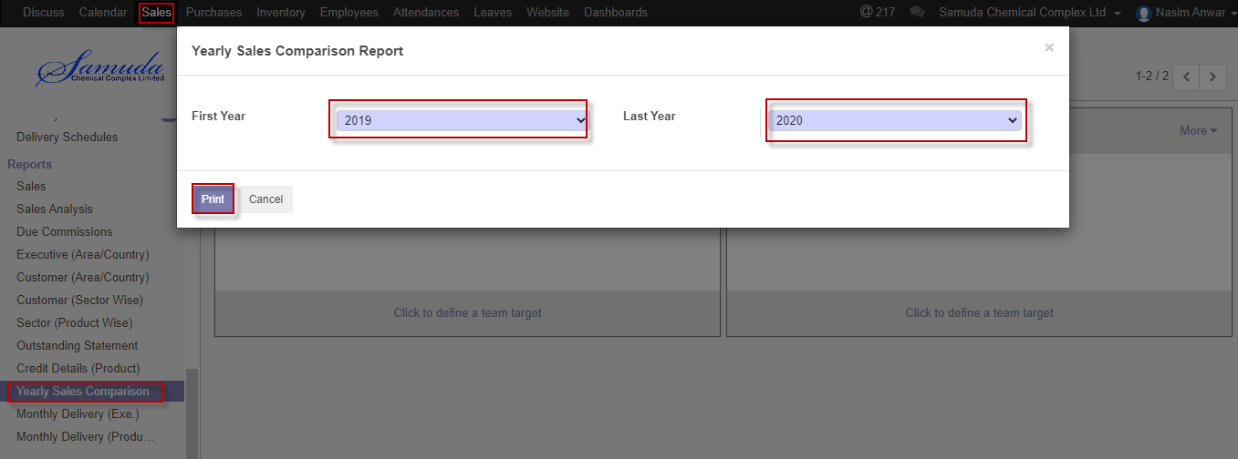

Figure: Yearly Sales Comparison) reports print view

We need to set the following:-

**Fiscal Year**: Select Fiscal year.

**Last Year**: Select last year.

After entering all information click **Print**.

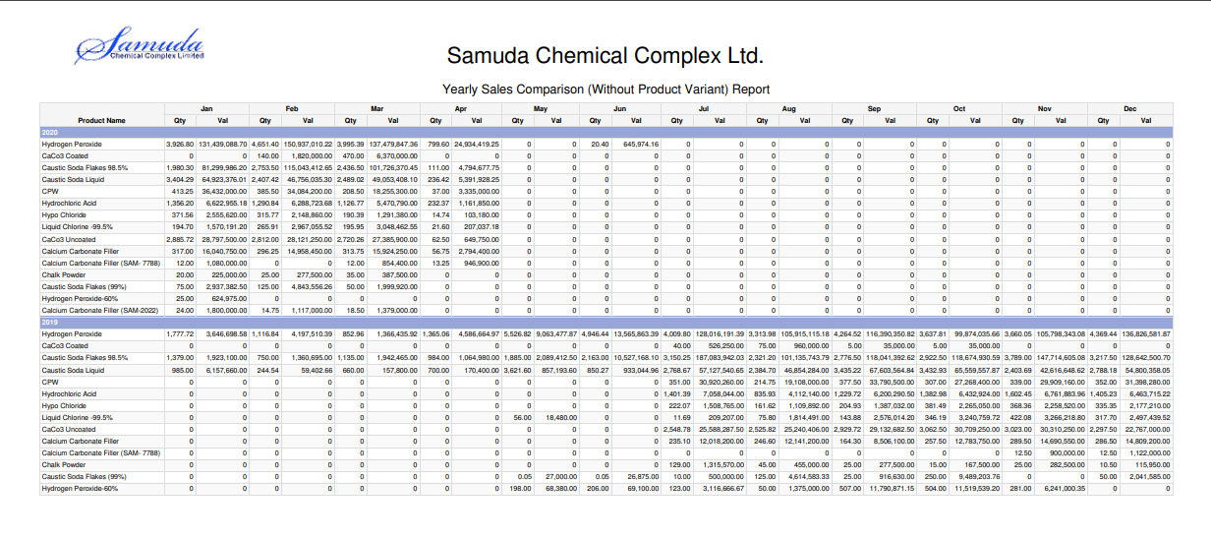

Figure: Yearly Sales Comparison) reports PDF format

## 25.15 Monthly Delivery statement (Executive wise) reports view by Admin

To see Monthly Delivery statement (Executive wise) reports use the menu **Sales ‣Reports>Monthly Delivery Statement (Executive wise)**

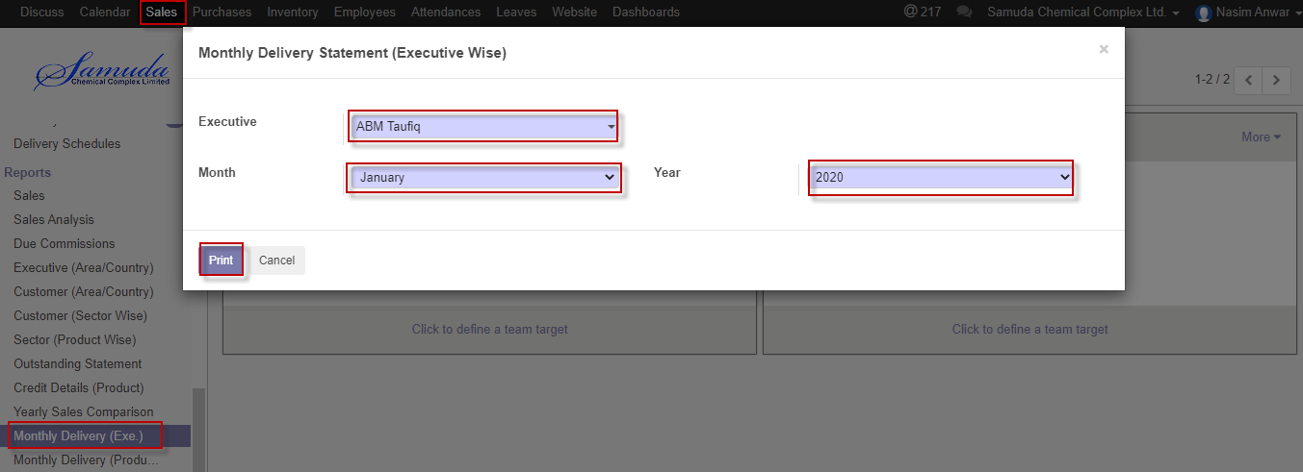

Figure: Monthly Delivery statement (Executive wise) reports print view

We need to set the following:-

**Executive**: Select Executive.

**Month:** Select month

**Year**: Select year.

After entering all information click **Print**.

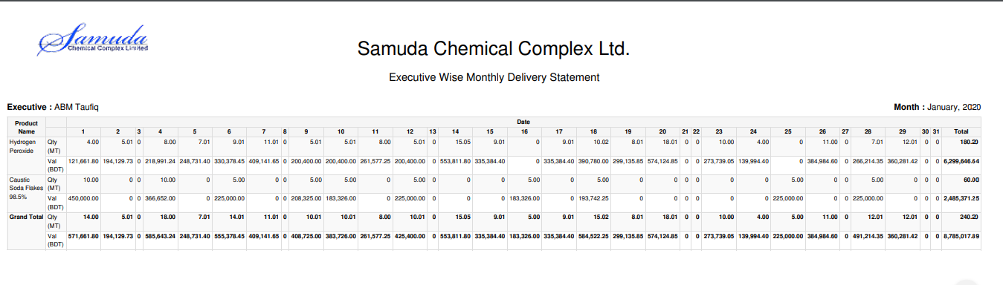

Figure: Monthly Delivery statement (Executive wise) reports PDF format

## 25.16 Monthly Delivery statement (Product wise) reports view by Admin

To see Monthly Delivery statement (Product wise) reports use the menu **Sales ‣Reports>Monthly Delivery Statement (Product wise)**



Figure: Monthly Delivery statement (Product wise) reports print view

We need to set the following:-

**Executive**: Select Executive.

**Month:** Select month

**Year**: Select year.

After entering all information click **Print**.

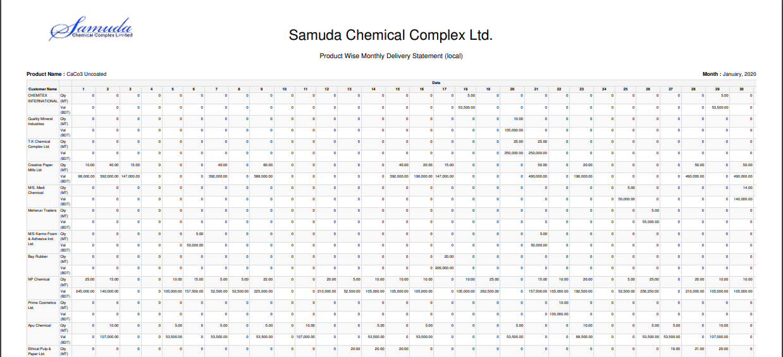

Figure: Monthly Delivery statement (Product wise) reports PDF format